Name

Mathematics Advanced Year 12
Quadratic and Cubic Functions

Book 1 |  | Version: 261015  Feedback:  https://MrDingMaths.com
Contents
Syllabus Content 2
Learning Intention 3

Syllabus Content
Quadratic and cubic functions
- Identify the $x$-intercepts of a parabola whose quadratic function is expressed in factored form
- Use the discriminant to determine the number of $x$-intercepts on a parabola and justify its position in relation to the $x$-axis
- Show by completing the square on the general quadratic $y=ax^{2}+bx+c$ that the axis of symmetry is $x=-\frac{b}{2a}$ where $a$, $b$ and $c$ are constants
- Identify the axis of symmetry and vertex of a parabola by completing the square on its quadratic function
- Choose and apply appropriate techniques to graph a parabola of the form $y={ax}^{2}+bx+c$ by identifying its $x$-intercepts if they exist, its $y$-intercept, its axis of symmetry using $x=-\frac{b}{2a}$ and its vertex
- Find the equation of a parabola given sufficient graphical features
- Use the fact that two quadratic functions are equal for all values of $x$ if and only if the corresponding coefficients are equal to solve related problems
- Recognise that solving $f\left(x\right)=k$ for some constant $k$ corresponds to finding the $x$-coordinate(s) of the intersection of the graphs $y=f\left(x\right)$ and $y=k$
- Solve problems by finding the solution to simultaneous equations involving a linear and a quadratic function, or two quadratic functions, both algebraically and graphically
- Solve quadratic inequalities
- Recognise and graph cubic functions of the form $f(x)=kx^{3}$ and $f\left(x\right)=k\left(x-a\right)\left(x-b\right)\left(x-c\right)$, where $a$, $b$, $c$ and $k$ are constants and $k≠0$

Sketching Parabolas by Factorisation

- General Form of a Parabola
The general form of a parabola tells us the concavity and $y$-intercept.

$$y=ax^{2}+bx+c$$

Concavity $y$-intercept

- Identify $y$-intercept and concavity from the equation of a parabola
- $y=x^{2}-2x-15$  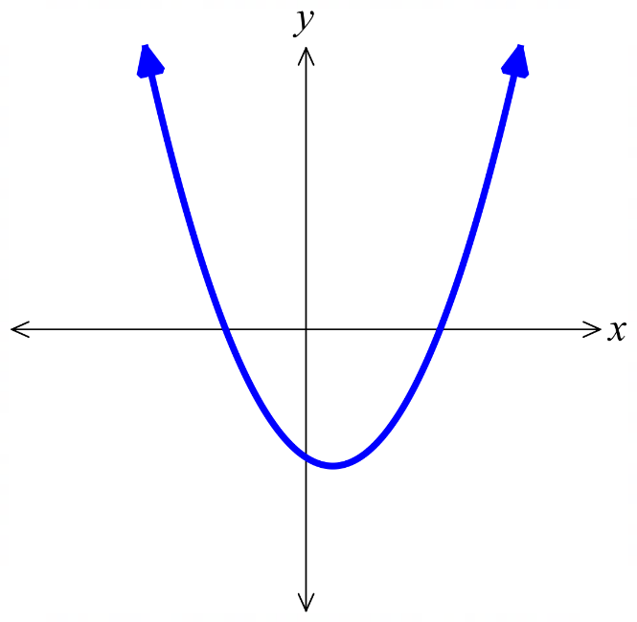  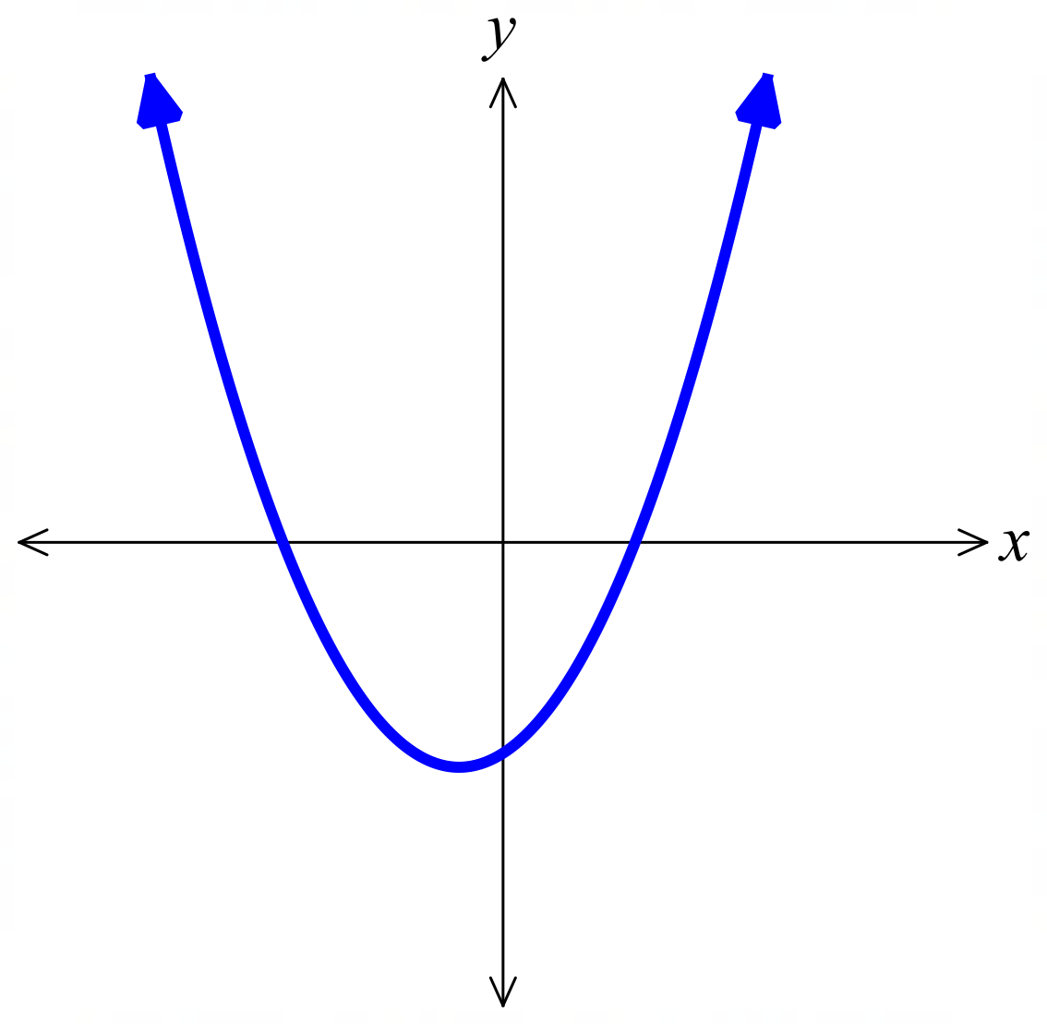  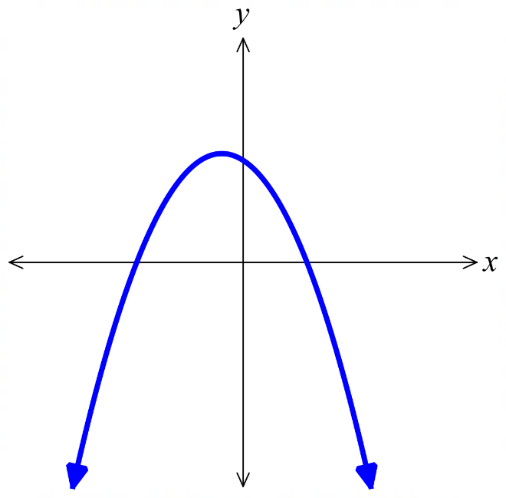 | - $y=x^{2}+2x-15$ | - $y=-x^{2}-2x+15$
- $y=x^{2}-\frac{13}{2}x-\frac{7}{2}$  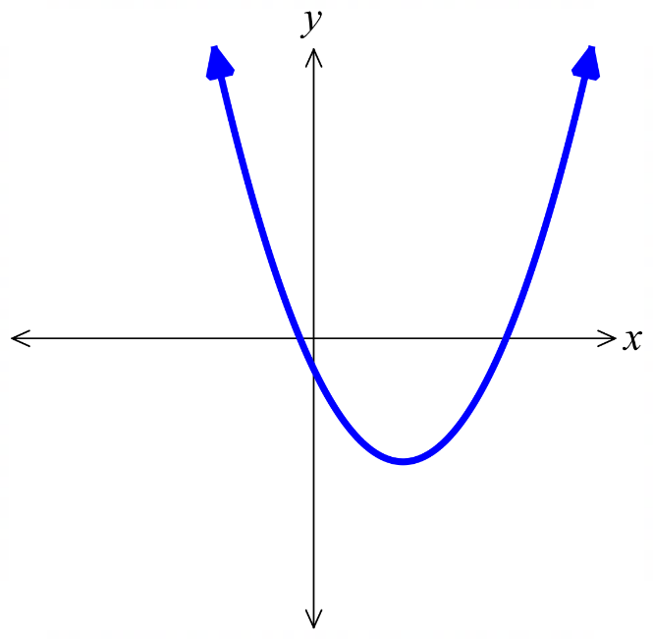 | - $y=2x^{2}+4x-16$  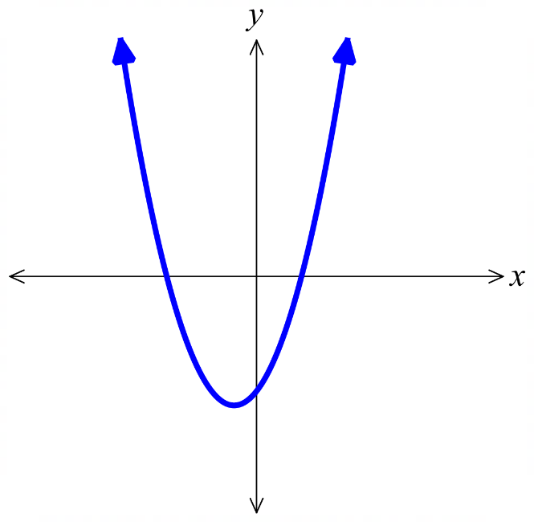 | - $y=x^{2}+4x$  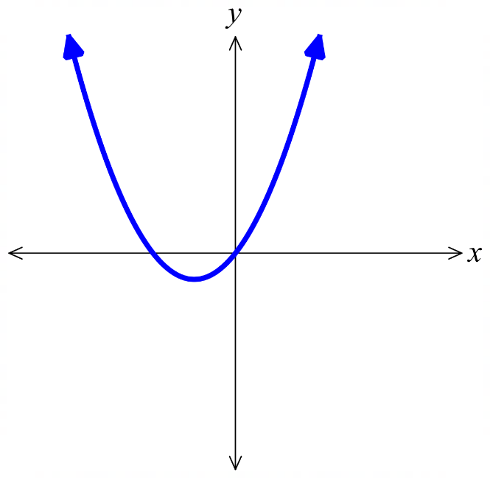
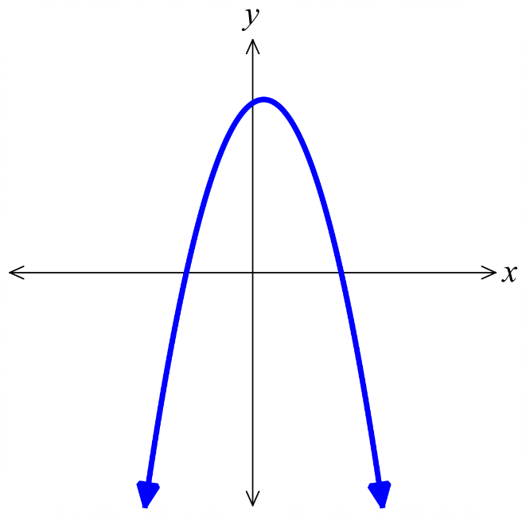  - $y=-x^{2}+4x$  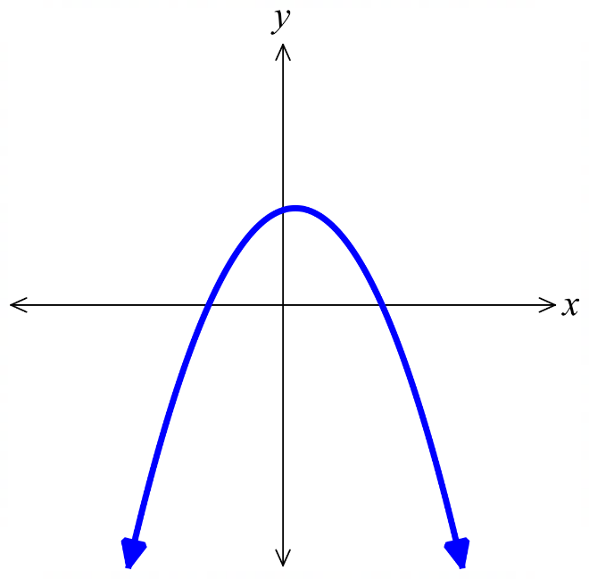  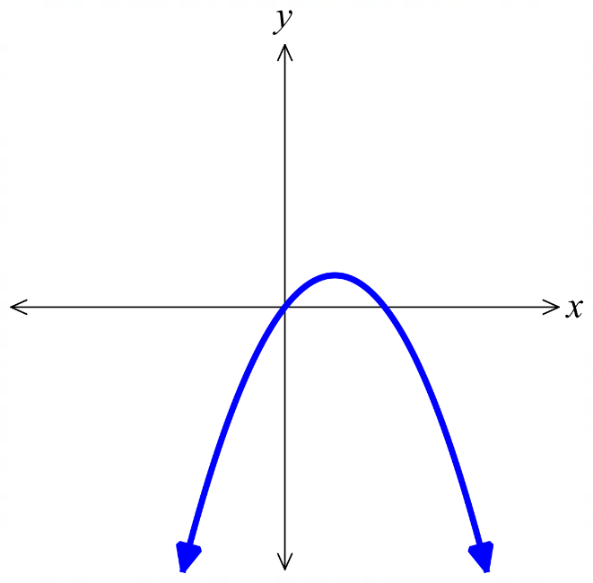 | - $y=-x^{2}+x+12$ | - $y=-2x^{2}+2x+24$
- Intercept Form of a Parabola
The intercept form of a parabola reveals its $x$-intercepts, since setting $y=0$ allows the solutions to be found using the null factor law.

$$y=a\left(x-α\right)\left(x-β\right)$$

Concavity $x$-intercepts

- Identify $x$-intercepts from the equation of a parabola
- $y=\left(x+3\right)\left(x-5\right)$ | - $y=\left(x-3\right)\left(x+5\right)$ | - $y=-\left(x-3\right)\left(x+5\right)$
- $y=\left(x+\frac{1}{2}\right)\left(x-7\right)$ | - $y=\left(2x+8\right)\left(x-2\right)$ | - $y=x\left(x+4\right)$
- $y=x(4-x)$ | - $y=\left(x+3\right)\left(4-x\right)$ | - $y=\left(2x+6\right)\left(4-x\right)$
- Sketch Parabolas by Factorisation
- Factorise $y=ax^{2}+bx+c$ to $y=a\left(x-α\right)\left(x-β\right).$
- Determine the concavity. $a>0$, concave up U $a<0$, concave down ∩.
- Find the $y$-intercept, $x=0$.
- Find the $x$-intercepts, if any. $y=0$.
- Determine the turning point.
Use the mean of the $x$-intercepts to find the $x$-coordinate,
then substitute into the equation to find the $y$-coordinate.

- Example Sketch parabolas from factored form
Sketch $y=x^{2}-6x+5$
0. Factorise: $y=\left(x-5\right)\left(x-1\right)$  1. Concavity: $a>0$, concave up  2. $y$-int: Let $x=0$  $y=5$  3. $x$-int: Let $y=0$  $0=\left(x-5\right)\left(x-1\right)$  $x=5$ or $1$  4. TP: Avg of $x$-intercepts: $\frac{1+5}{2}$ $=3$  Sub $x=3$ into equation  $y=3^{2}-6\left(3\right)+5$  $y=-4$ | 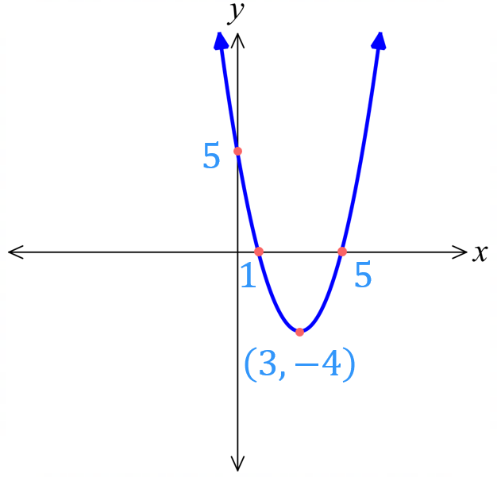

- Guided Practice
Sketch $y=x^{2}+4x-12$
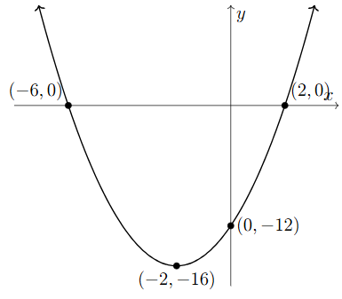
0. Factorise:

1. Concavity:
2. $y$-int:

3. $x$-int:

4. TP:
- Guided Practice
- $y=-x^{2}+4x$
0. Factorise:

1. Concavity:

2. $y$-int:
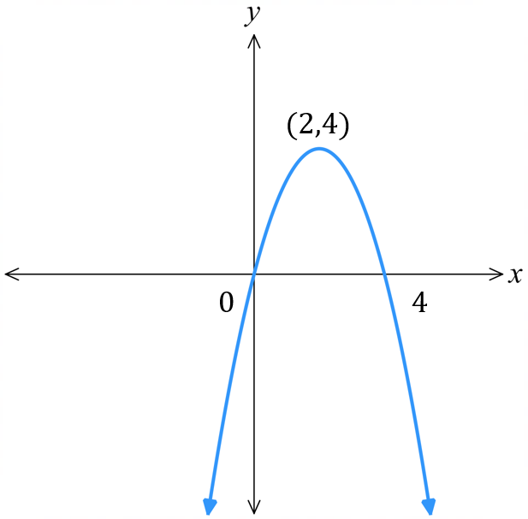

3. $x$-int:

4. Vertex:

- $y=2x^{2}+7x+5$
0. Factorise:

1. Concavity:

2. $y$-int:
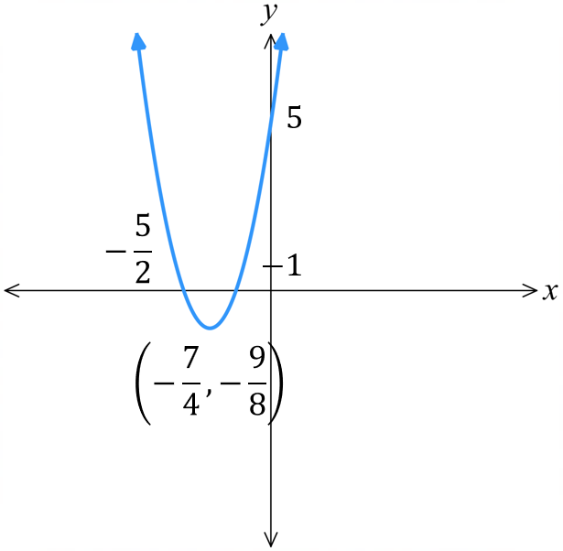

3. $x$-int:

4. Vertex:

Parabola Transformations

- Parabola Transformations
For a parabola $y=k{\left(x-b\right)}^{2}+c$
$k>0$, the parabola is concave ……………,  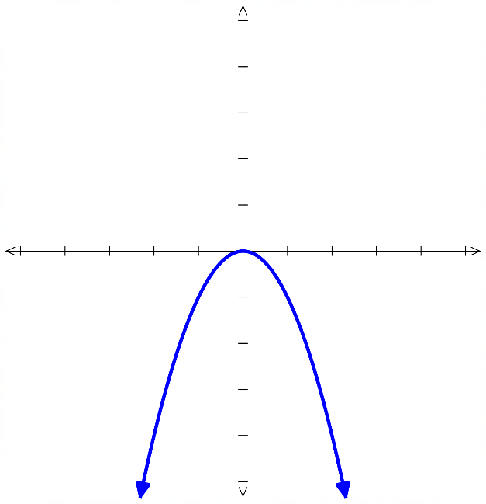  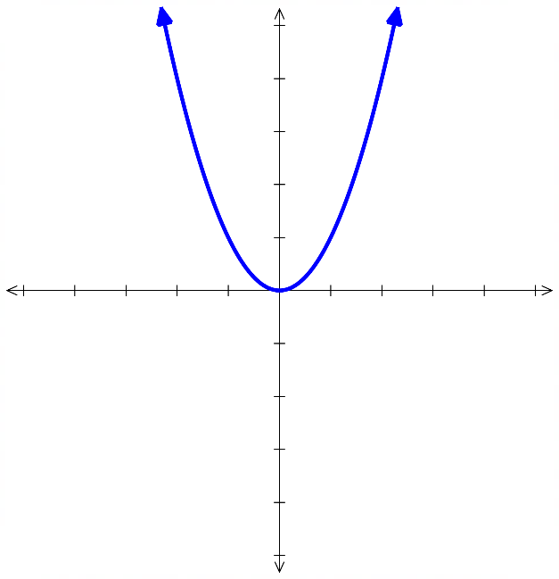  with a ………………… turning point.  $$y=1x^{2}$$ | $k<0$, the parabola is concave ……………,  with a ……………… turning point.  $$y=-1x^{2}$$
$b>0$, the parabola is shifted ……………  $$y={\left(x-3\right)}^{2}$$ | $b<0$, the parabola is shifted ……………  $$y={\left(x+3\right)}^{2}$$  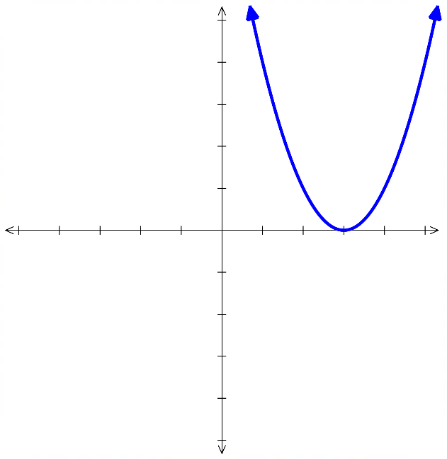  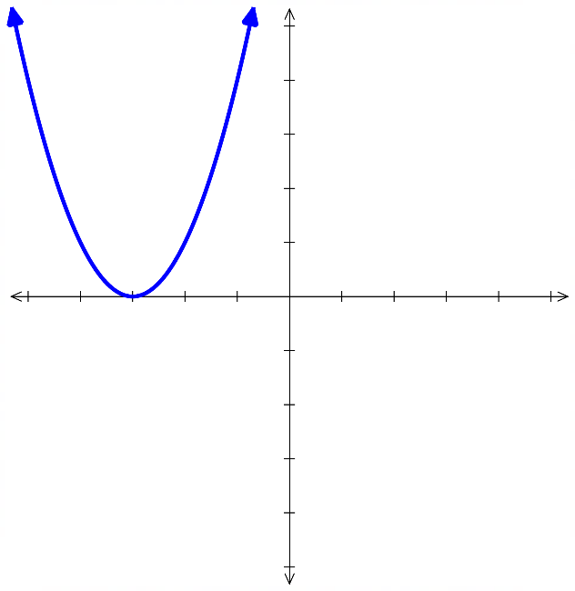
$c>0$, the parabola is shifted ……………  $$y=x^{2}+3$$ | $c<0$, the parabola is shifted ……………  $$y=x^{2}-3$$  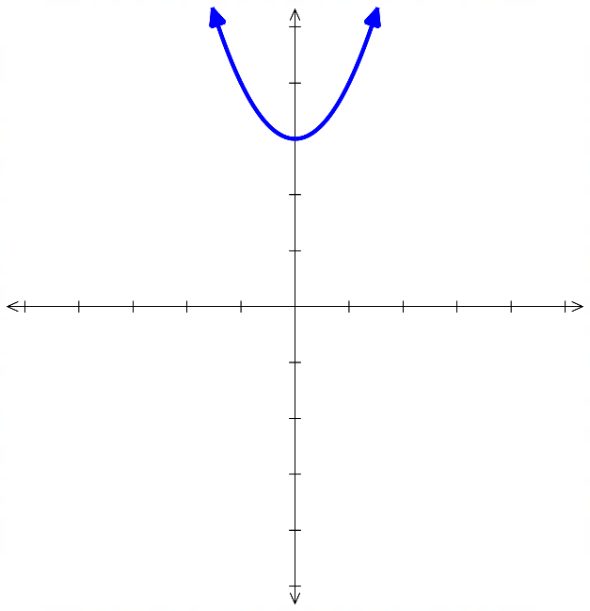  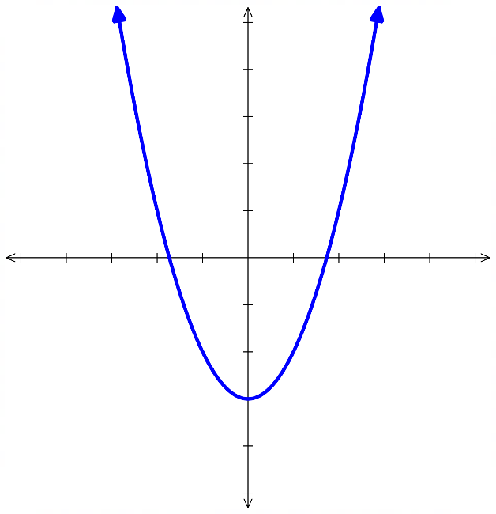
$\left|k\right|>1$, the parabola gets …………….  $$y=5x^{2}$$  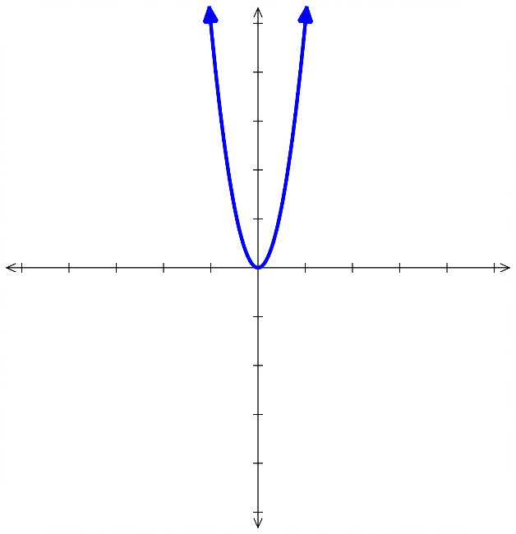 | $0<\left|k\right|<1,$ the parabola gets ……………….  $$y=\frac{1}{5}x^{2}$$  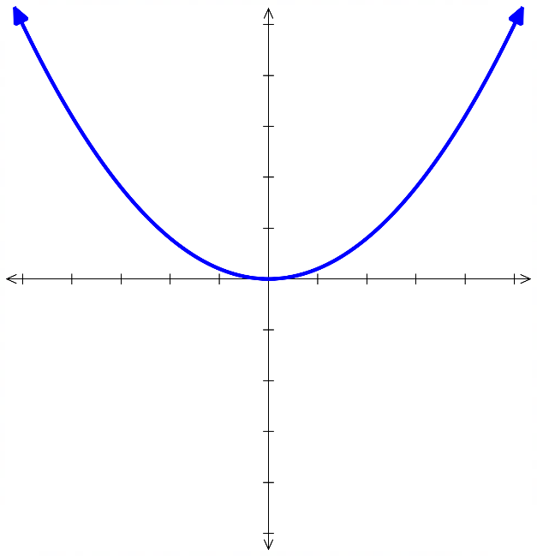
- Vertex Form of a Parabola
The vertex form of a parabola reveals its turning point because it shows the graph’s horizontal and vertical shifts.

$$y=a{\left(x-h\right)}^{2}+k$$

Concavity turning point $\left(h,k\right)$

- Identify turning point of a parabola
Equation | Turning Point (Vertex)
$y=3{\left(x-4\right)}^{2}+2$ | $$\left(4,2\right)$$
$y=3{\left(x-4\right)}^{2}-2$ | $$\left(4,-2\right)$$
$y=-3{\left(x-4\right)}^{2}-2$ | $$\left(4,-2\right)$$
$y=-3{\left(x+4\right)}^{2}-2$ | $$\left(-4,-2\right)$$
$y=-3{\left(x+4\right)}^{2}+2$ | $$\left(-4,2\right)$$
$$y=\frac{1}{3}{\left(x+4\right)}^{2}+2$$ | $$\left(-4,2\right)$$
$$y=\frac{{\left(x+4\right)}^{2}}{3}+2$$ | $$\left(-4,2\right)$$
$$y=\frac{{\left(x+4\right)}^{2}+2}{3}$$ | $$\left(-4,\frac{2}{3}\right)$$
$y={\left(x+4\right)}^{2}+2$ | $$\left(-4,2\right)$$
$y={\left(x+4\right)}^{2}$ | $$\left(-4,0\right)$$
$y=x^{2}$ | $$\left(0,0\right)$$
$y=x^{2}+5$ | $$\left(0,5\right)$$
$$y=\frac{x^{2}}{5}$$ | $$\left(0,0\right)$$
$y=-9{\left(x+1\right)}^{2}-5$ | $$\left(-1,-5\right)$$

Sketching Parabolas from Vertex Form

- Sketch Parabolas from Vertex Form
To sketch $y=a{\left(x-h\right)}^{2}+k$:
- Determine the concavity.
$a>0$, concave up U $a<0$ concave down ∩.
- Find the $y$-intercept. Substitute $x=0$.
- Find the $x$-intercepts, if any. Substitute $y=0$.
- Determine the vertex. Using $\left(h,k\right)$.

- Example Sketch a parabola from vertex form
Sketch $y={\left(x-3\right)}^{2}-2$
1. Concavity: $a>0$, concave up.  2. $y$-int: Let $x=0$  $y={\left(0-3\right)}^{2}-2=7$  3. $x$-int: Let $y=0$  $0={\left(x-3\right)}^{2}-2$  $2={\left(x-3\right)}^{2}$  $±\sqrt{2}=x-3$  $3±\sqrt{2}=x$  $x$-ints at $3+\sqrt{2}$ and $3-\sqrt{2}$  4. Vertex: $\left(3,-2\right)$ | 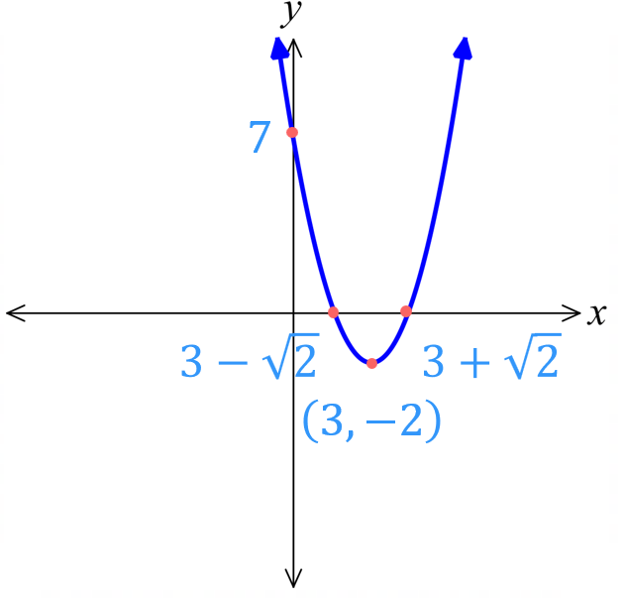

- Guided Practice
Sketch $y={\left(x+3\right)}^{2}-1$
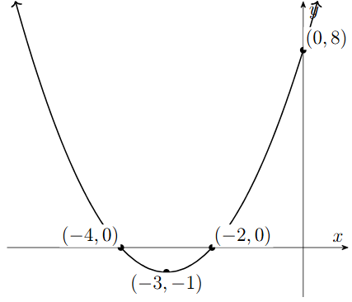
1. Concavity:
2. $y$-int:
3. $x$-int:

4. Vertex:

- Guided Practice
- $y=-{\left(x+1\right)}^{2}+4$
1. Concavity:
2. $y$-int:

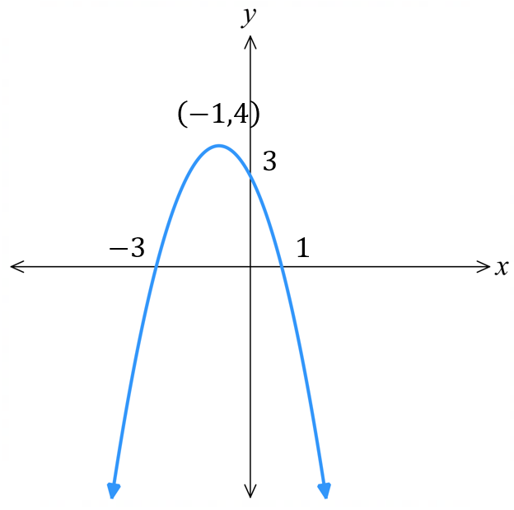
3. $x$-int:

4. Vertex:

- $y=-2{\left(x-3\right)}^{2}-2$
1. Concavity:
2. $y$-int:

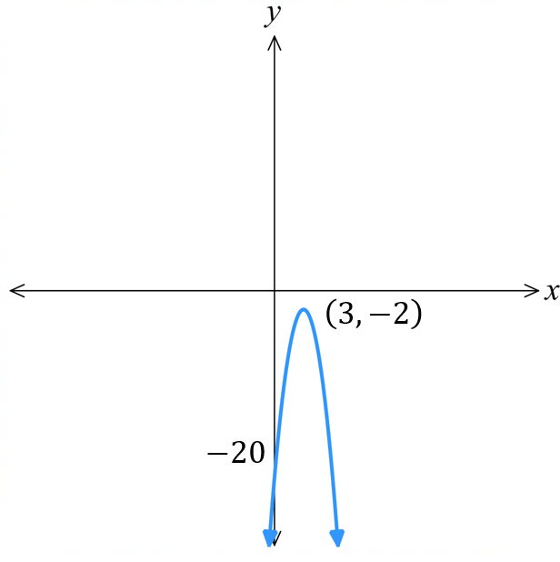
3. $x$-int:

4. Vertex:

Sketching Parabolas by Completing the Square

- Sketch Parabolas by Completing the Square
- When factorising by PSF is not possible, complete the square to write a quadratic in vertex form.
- Write in vertex form: halve the coefficient of $x$, square it, then add and subtract this value.
- Concavity
- $y$-int
- $x$-int
- Vertex

- Example Sketch parabolas by completing the square
Sketch $y=x^{2}-4x-5$  0. Vertex form by CTS  $y=x^{2}-4x+4-4-5$  $y=\left(x^{2}-4x+4\right)-4-5$  $y={\left(x-2\right)}^{2}-9$  1. Concavity $a>0$, concave up.  2. $y$-int: Let $x=0,$  $y={\left(0-2\right)}^{2}-9=-5$  3. $x$-int: Let $y=0$  ${\left(x-2\right)}^{2}-9=0$  ${\left(x-2\right)}^{2}=9$  $x-2=±3$  $x=2±3$  $x=5$ or $-1$  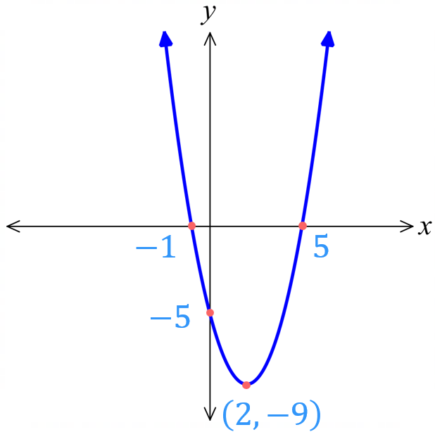  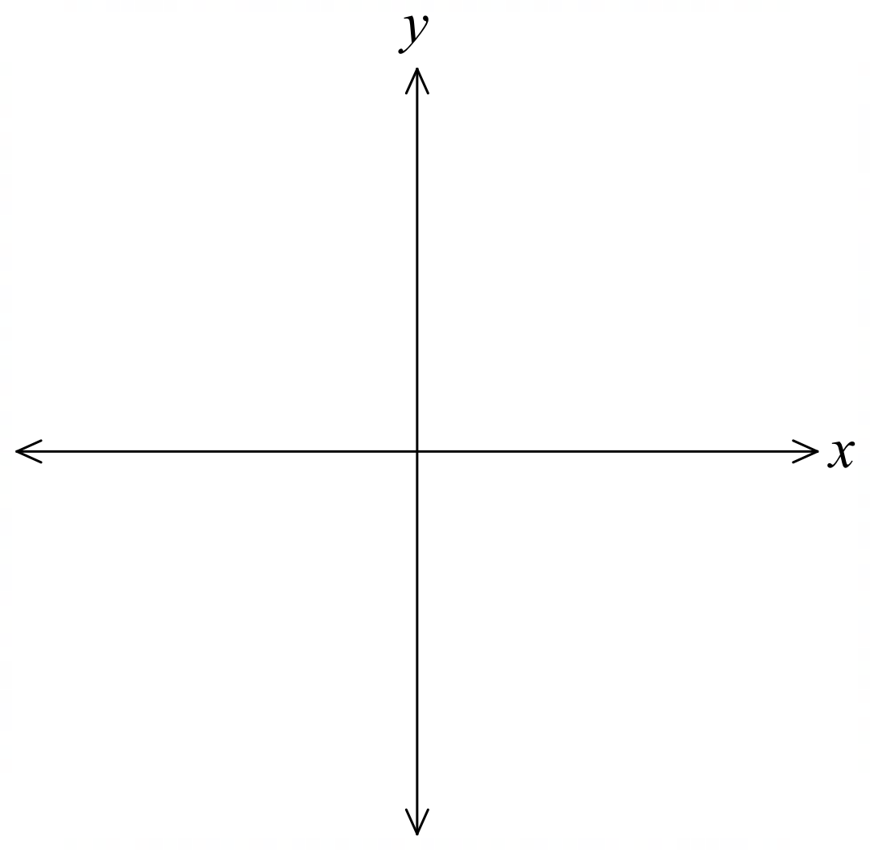  4. Vertex: $\left(2,-9\right)$ | Sketch $y=x^{2}+6x+15$  0. Vertex form by CTS  1. Concavity  2. $y$-int:  3. $x$-int:  4. Vertex:  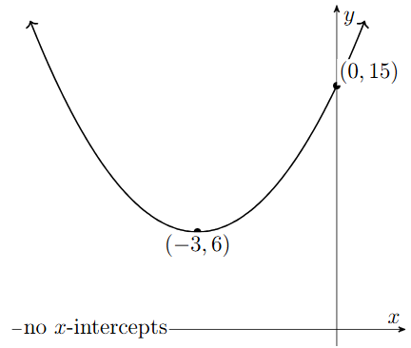
- Guided Practice
- $y=x^{2}-4x-1$  0. Vertex form by CTS  1. Concavity  2. $y$-int:  3. $x$-int:  4. Vertex:  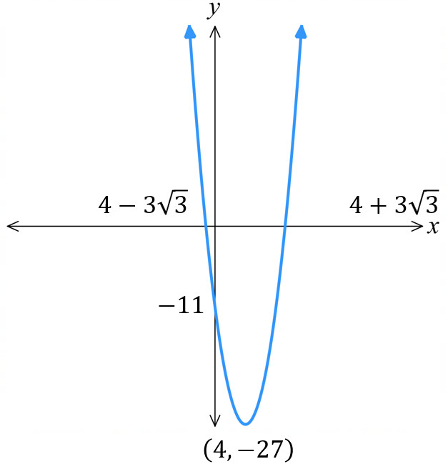  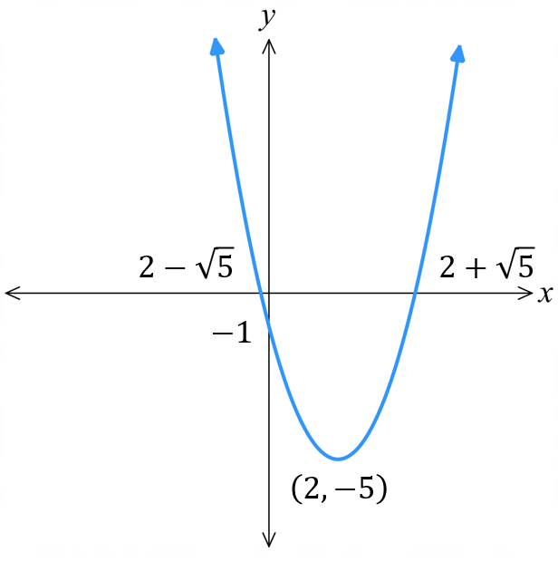 | - $y=x^{2}-8x-11$  0. Vertex form by CTS  1. Concavity  2. $y$-int:  3. $x$-int:  4. Vertex:

Sketching Parabolas by Quadratic Formula

- Sketching Parabolas by Quadratic Formula
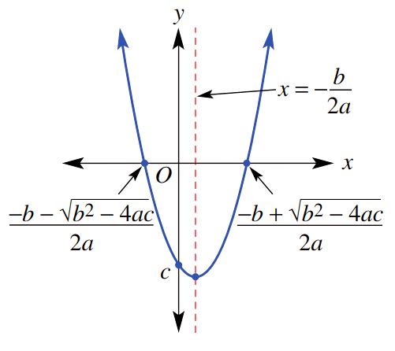
Instead of completing the square, we can use the quadratic formula to sketch instead.
- Concavity.
- $y$-int.
- $x$-ints using $x=$ $\frac{-b±\sqrt{b^{2}-4ac}}{2a}$
- Vertex using $x=-$ $\frac{b}{2a}$,
then substitute value of $x$ into the equation to find $y$.

- Example Sketch parabolas by quadratic formula
Sketch $y=-x^{2}+6x+1$  1. Concavity: $a<0$, concave down.  2. $y$-int: Let $x=0$,  $y=1$  3. $x$-int:  $$x=\frac{-6±\sqrt{6^{2}-4\left(-1\right)\left(1\right)}}{2\left(-1\right)}$$  $$=\frac{-6±\sqrt{40}}{-2}$$  $$=\frac{-6±2\sqrt{10}}{-2}$$  $=3±\sqrt{10}$  4. Vertex:  $$x=\frac{-6}{2\left(-1\right)}=3$$  $y=-{\left(3\right)}^{2}+6\left(3\right)+1$  $=10$  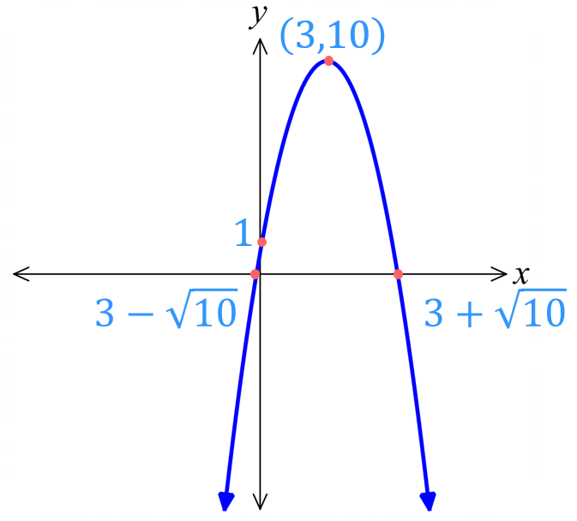  Vertex at $\left(3,10\right)$ |  | Sketch $y=x^{2}+4x+1$  1. Concavity:  2. $y$-int:  3. $x$-int:  4. Vertex:  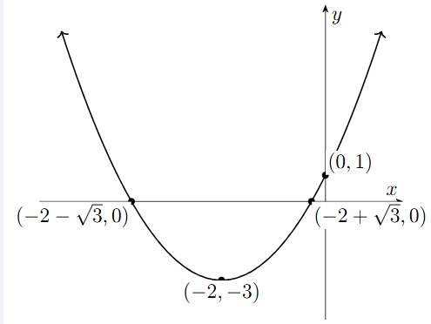
- Guided Practice
- $y=x^{2}-2x-1$  1. Concavity:  2. $y$-int:  3. $x$-int:  4. Vertex: |  | - $y={5x}^{2}-20x+20$  1. Concavity:  2. $y$-int:  3. $x$-int:  4. Vertex:  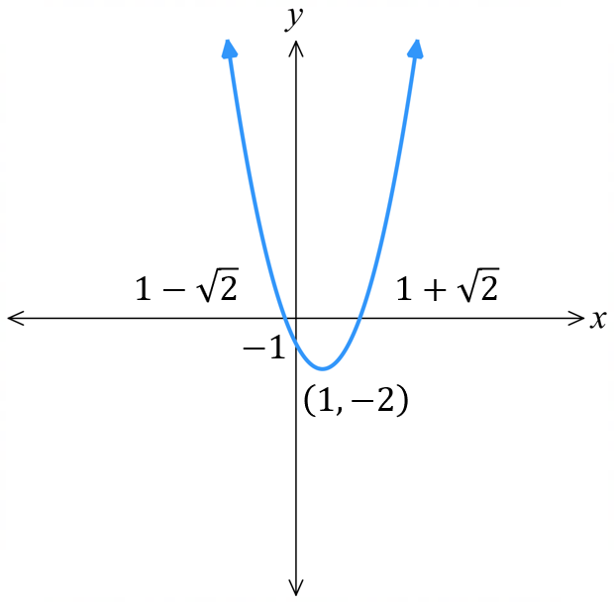  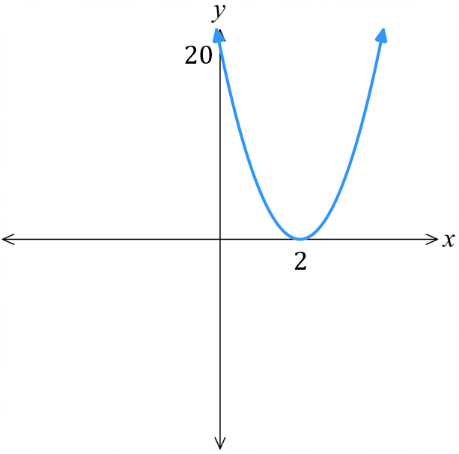
- The Discriminant and the Graph
The discriminant $Δ=b^{2}-4ac$ tells how many solutions, or $x$-intercepts, a quadratic has.
Check the discriminant first; it tells you if $x$-intercepts exist.
$$Δ>0$$  2 solutions | $$Δ=0$$  1 solution  We say the parabola is tangent to the $x$-axis. |  | $$Δ<0$$  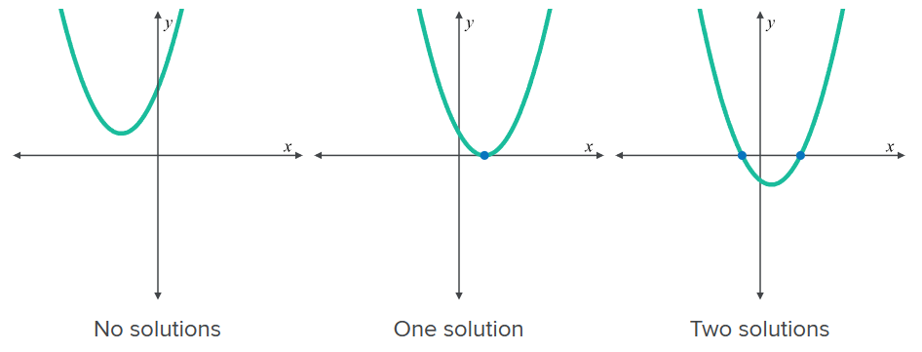  No real solutions

- Example Sketch parabolas by checking the discriminant first
Sketch $y=3x^{2}-6x+4$  1. Concavity: $a>0$, concave up.  2. $y$-int: Let $x=0$,  $y=4$  3. $x$-int:  $Δ=b^{2}-4ac$  $={\left(-6\right)}^{2}-4\left(3\right)\left(4\right)$  $=-12$  No $x$ intercepts.  4. Vertex:  $$x=\frac{-b}{2a}=\frac{-\left(-6\right)}{2\left(3\right)}=1$$  $y=3{\left(1\right)}^{2}-6\left(1\right)+4=1$  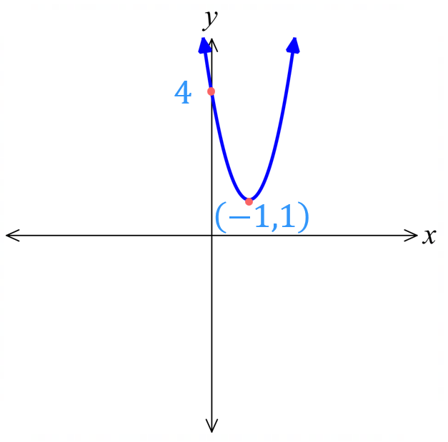  Vertex at $\left(1,1\right)$ | How did we know there were no  $x$-intercepts?  The value of the discriminant was ……………  What would have happened if you tried to use the quadratic formula?  You would be square rooting a ………………  How did finding the discriminant save us time?  We did not need to attempt to find the …… intercepts.  How did we find the vertex?  We found the $x$-coordinate using the formula …………, then substituted into the ………………… to find $y$.
- Guided Practice
Sketch these parabolas by checking the discriminant first.
$y=x^{2}-4x+5$  1. Concavity:  2. $y$-int:  3. $x$-int:  $Δ=b^{2}-4ac$  4. Vertex: | $y=-4x^{2}-13x-53$  1. Concavity:  2. $y$-int:  3. $x$-int:  $Δ=b^{2}-4ac$  4. Vertex:  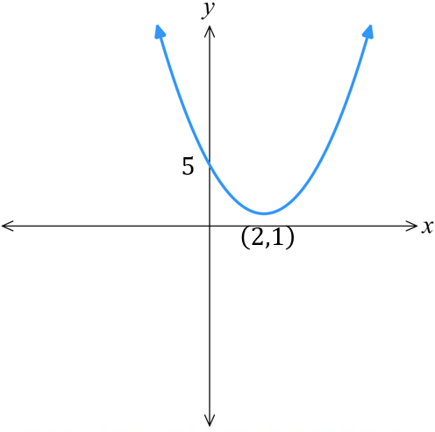  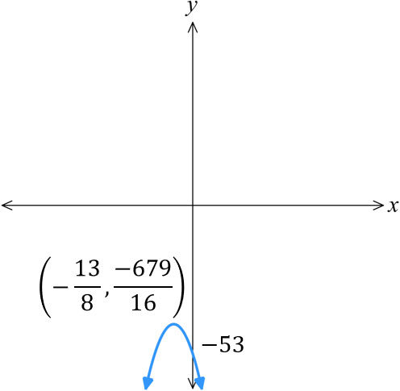

Finding the Equation of a Parabola from its Graph

Quadratic Inequalities

- Identify the region where $y>0$ or $y<0$
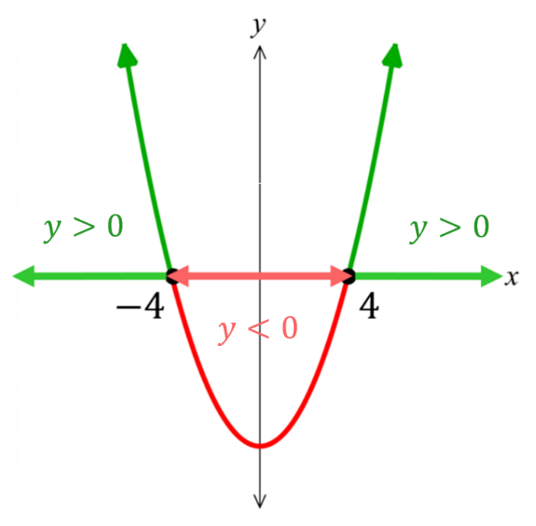  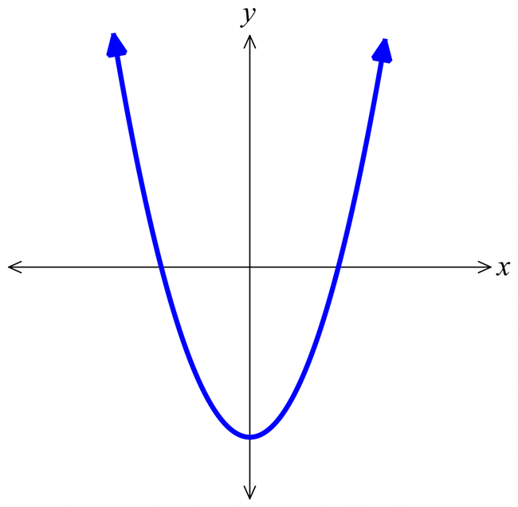  $y>0:$ $x<-4, x>4$  $y<0:$ $-4<x<4$ | 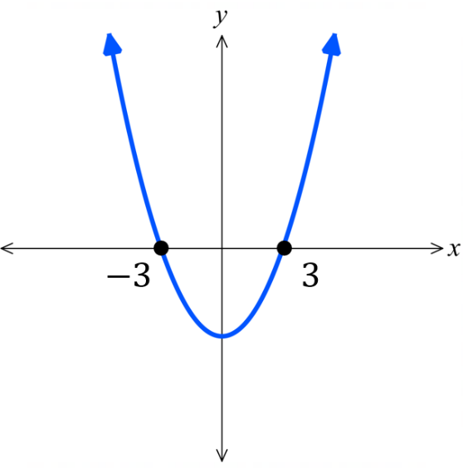  $y>0:$  $$x<-3, x>3$$  $y<0:$  $$-3<x<3$$ | 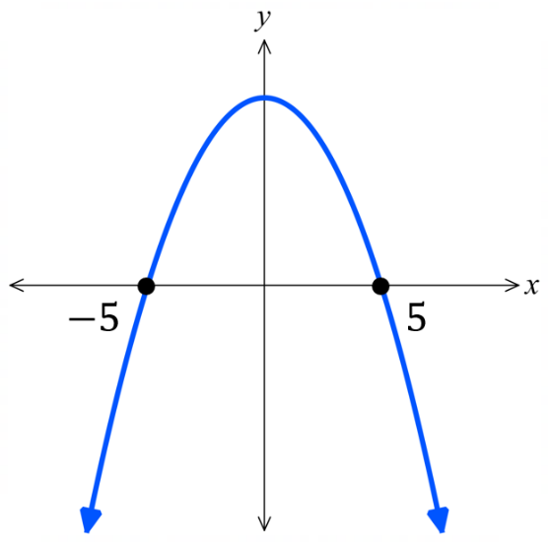  $y>0:$  $$-5<x<5$$  $y<0:$  $$x<-5, x>5$$
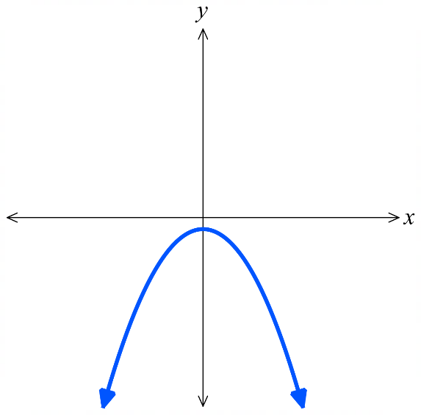  $y>0:$  no solution  $y<0:$  all real $x$ | 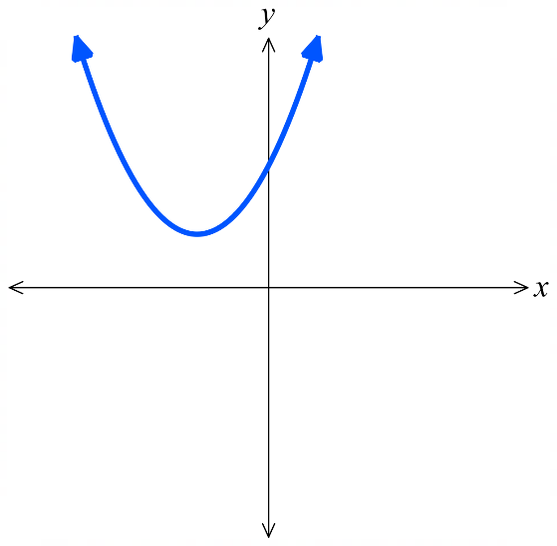  $y>0:$  all real $x$  $y<0:$  no solution | 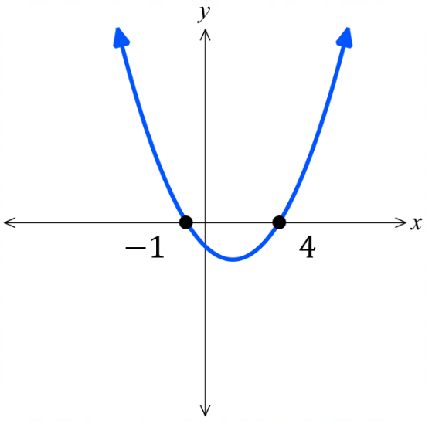  $y>0:$  $$x<-1, x>4$$  $y<0:$  $$-1<x<4$$
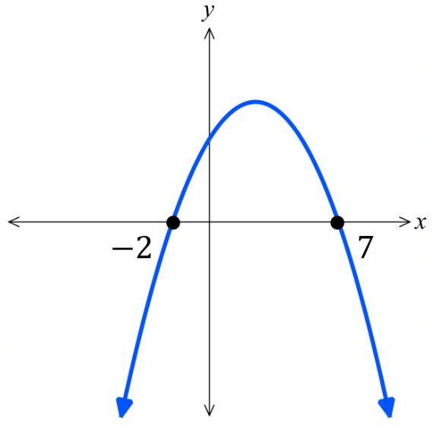  $y>0:$  $$-2<x<7$$  $y<0:$  $$x<-2, x>7$$ | 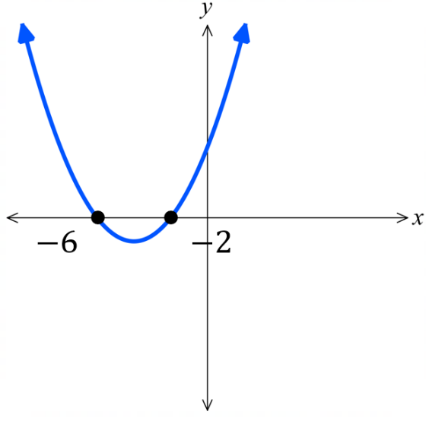  $y>0:$  $$x<-6, x>-2$$  $y<0:$  $$-6<x<-2$$

- Quadratic Inequalities
A quadratic inequality is an inequality in which the highest power of the pronumeral is $2$.
Solving quadratic inequalities is best done by sketching a parabola.

- Move all terms to one side so that you have $ax^{2}+bx+c≥0$ or $≤0$.
- Sketch the parabola $y=ax^{2}+bx+c$, showing all $x$-intercepts.
- Examine where the graph is above or below the $x$-axis.

- Example Solve quadratic inequalities using graphing techniques
Solve $x^{2}>9$  1.  $x^{2}-9>0$  2.  $\left(x+3\right)\left(x-3\right)>0$  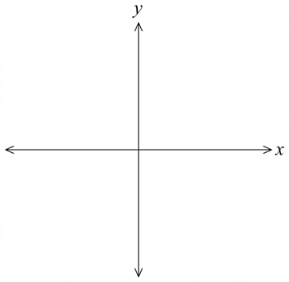  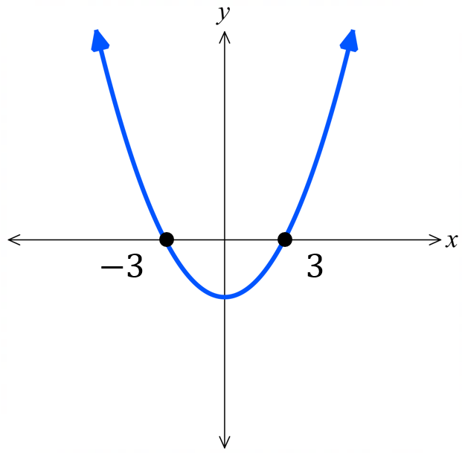  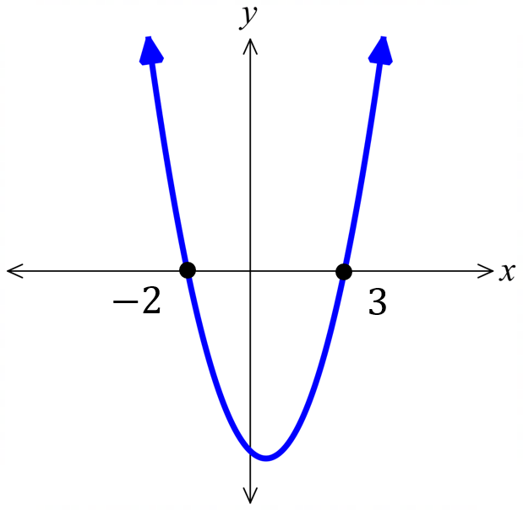  3. $x<-3$ or $x>3$ | Solve $x+6≥x^{2}$  1.  $-x^{2}+x+6≥0$  $x^{2}-x-6≤0$  2.  $\left(x-3\right)\left(x+2\right)≤0$  3. $-2≤x≤3$

- Guided Practice
- Solve $x^{2}+2x>0$  $$x<-2, x>0$$ | - Solve $x^{2}-x-12≤0$  $$-3≤x≤4$$

Points of Intersection of a Parabola and a Line

- Finding the points of Intersection of a Parabola and a Line
When you have two graphs: $y=ax^{2}+bx+c$ and $y=mx+d$. The point of intersection lies on both curves, so is the simultaneous solution to the equations.
1. Set the two $y$ values to be equal $y_{1}=y_{2}$
2. Solve for $x$ by rearranging the resulting quadratic equation.
3. Solve for $y$.

- Example Find points of intersection of a parabola and a line
Find the points of intersection of $y=x^{2}+4x+4$ and $y=16.$
1. $x^{2}+4x+4=16$
2. $x^{2}+4x-12=0$
$\left(x+6\right)\left(x-2\right)=0$
$x=-6 or 2$

3. when $x=-6$, $y=16$
when $x=2$, $y=16$
so, points of intersection are $\left(-6,16\right)$ and $(2,16)$

- Guided Practice
Find the points of intersection of:
- $y=x^{2}+6x+9$ and $y=25$
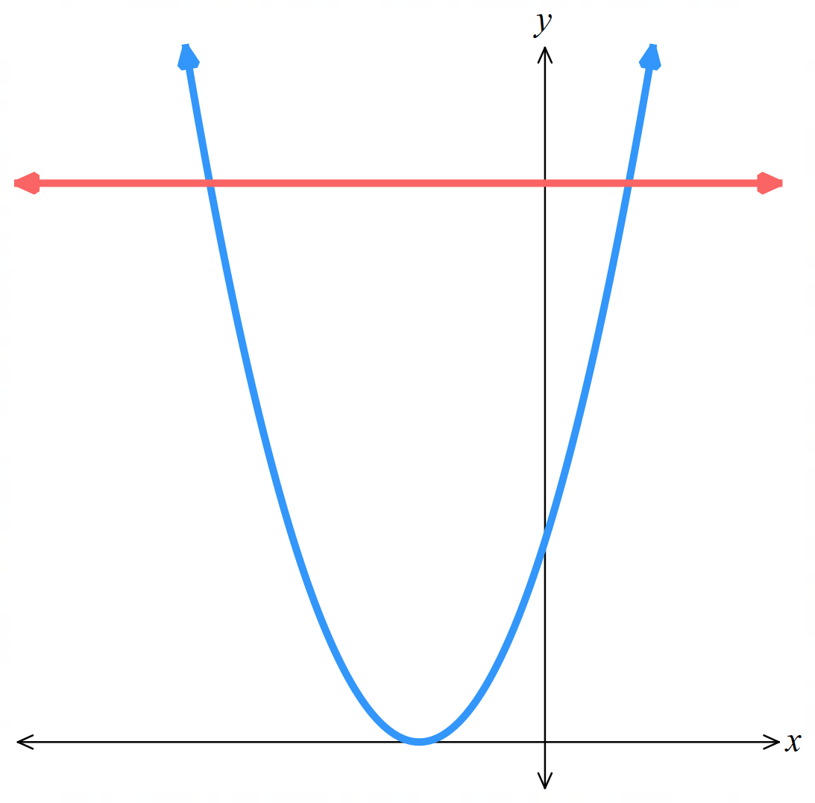

$\left(-8,25\right)$ and $\left(2,25\right)$
- $y=x^{2}+6x+9$ and $y=2x+9$
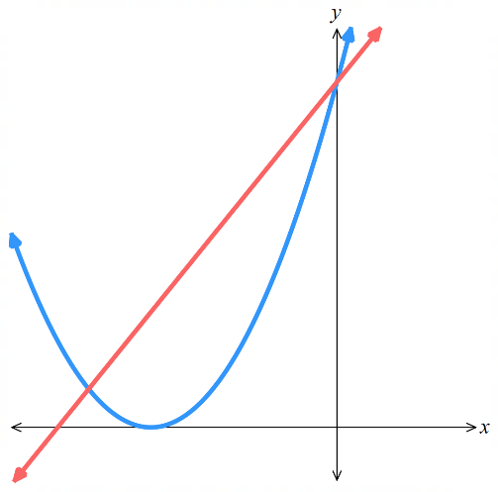

$\left(-4,1\right)$ and $\left(0,9\right)$
- $y=2x^{2}-5x-3$ and $y=3x+7$
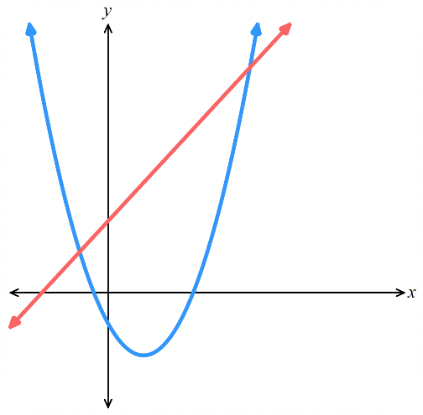

$\left(-1,4\right)$ and $\left(5,22\right)$
- The Discriminant and Points of Intersection
A parabola intersects a straight line at zero, one, or two points.
The discriminant of the resulting equation after setting the two equations equal reveals the number of points of intersection.
$$Δ=0$$  1 intersection point  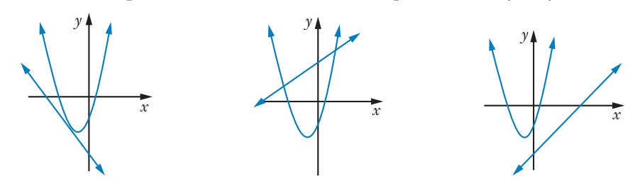  the line is tangent to the parabola | $$Δ>0$$  Two intersection points | $$Δ<0$$  No intersection points

- Investigation The discriminant and points of intersection
Consider the two graphs of $y=x^{2}-2x+1$ and $y=-2x+1.$
The graph shows that there is only one point of intersection.
Show that $Δ=0$ and then find the point of intersection.
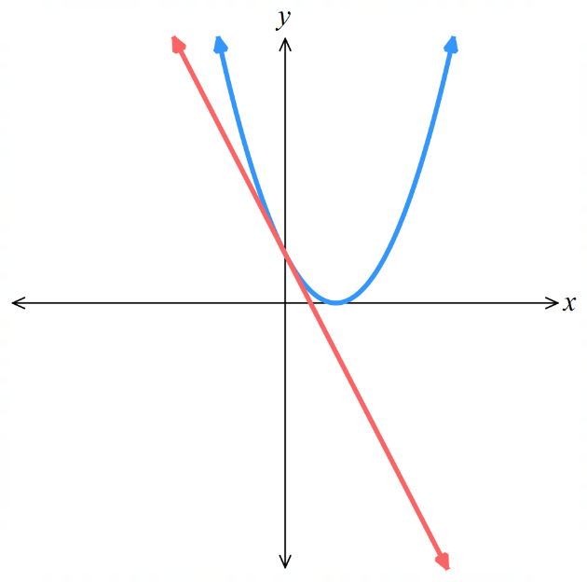

Consider the two graphs of $y=-2x^{2}+5x+3$ and $y=3x+7$.
The graph shows no points of intersection.
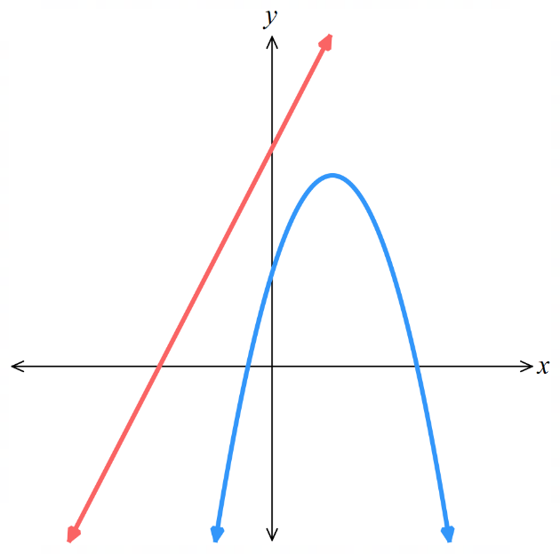
Find the value of $Δ$ and confirm this is true.

Cubic Curves and Transformations

- Cubic Curves
A cubic function has an equation where $x$ has a highest power of 3.
The most basic form is $y=kx^{3}$
The basic cubic curve has a point of inflection, where the concavity changes.
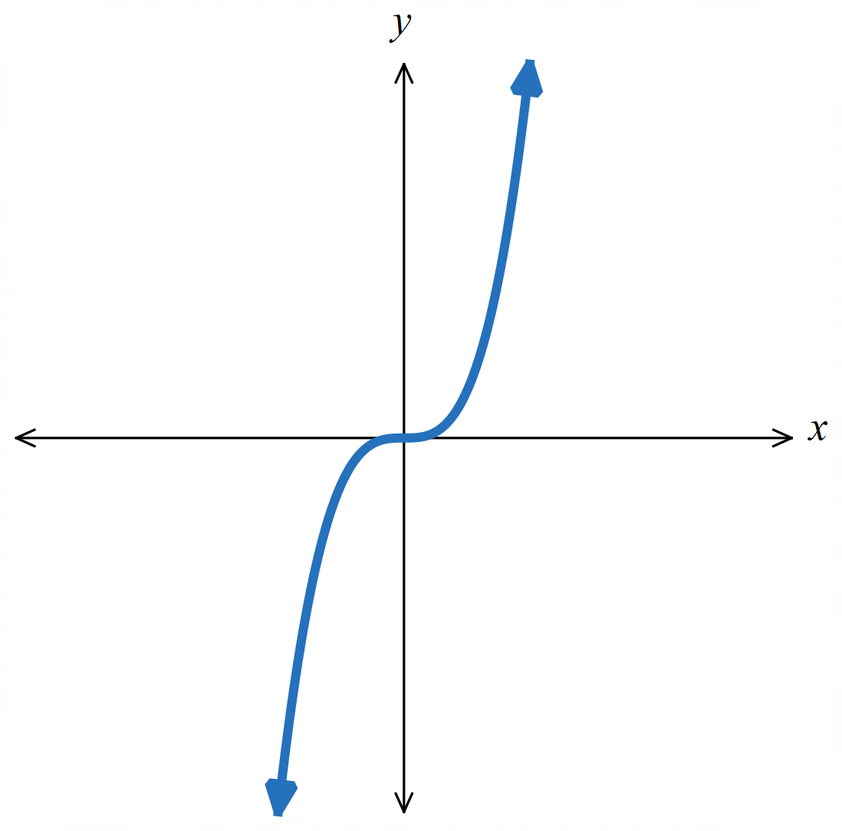

Point of inflection
This curve changes from concave down to concave up

- Investigation Graph cubic relationships using a table of values
Draw the graph of $y=x^{3}-2$  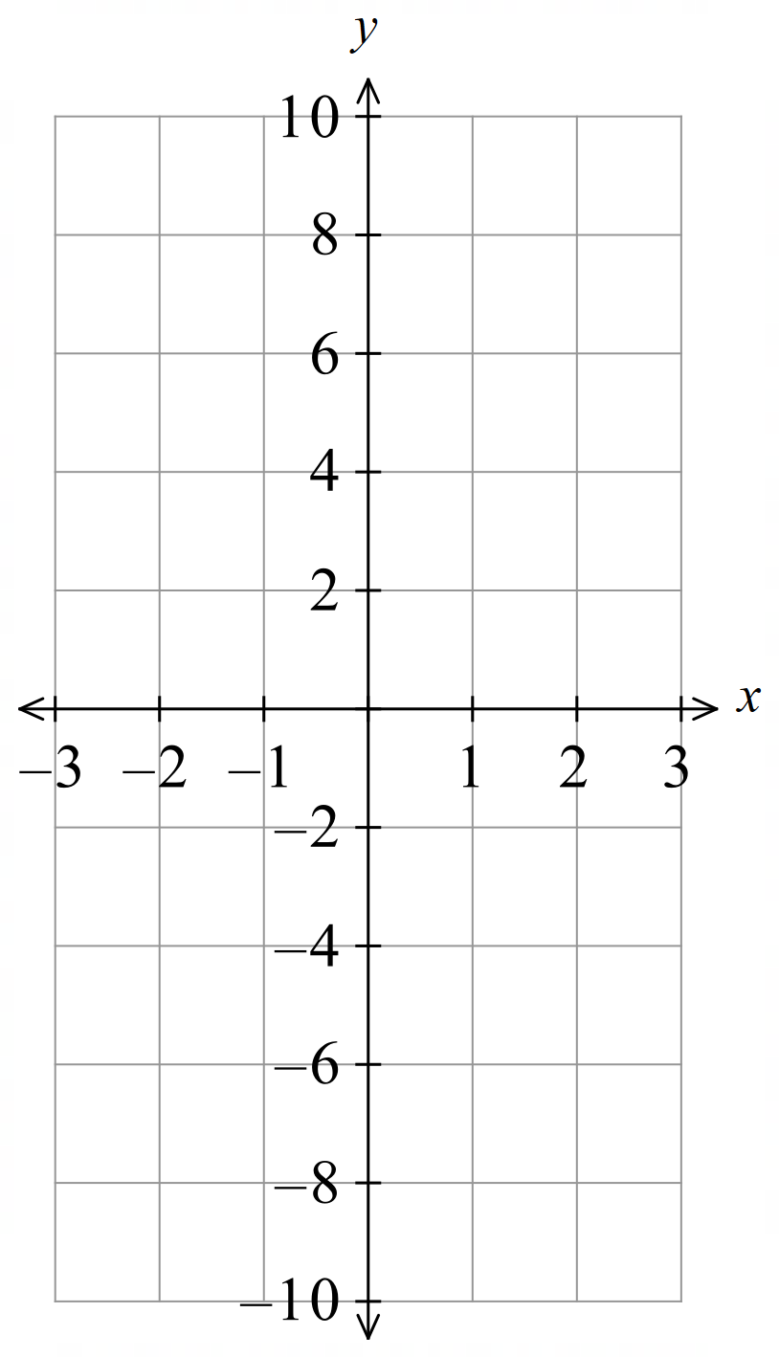  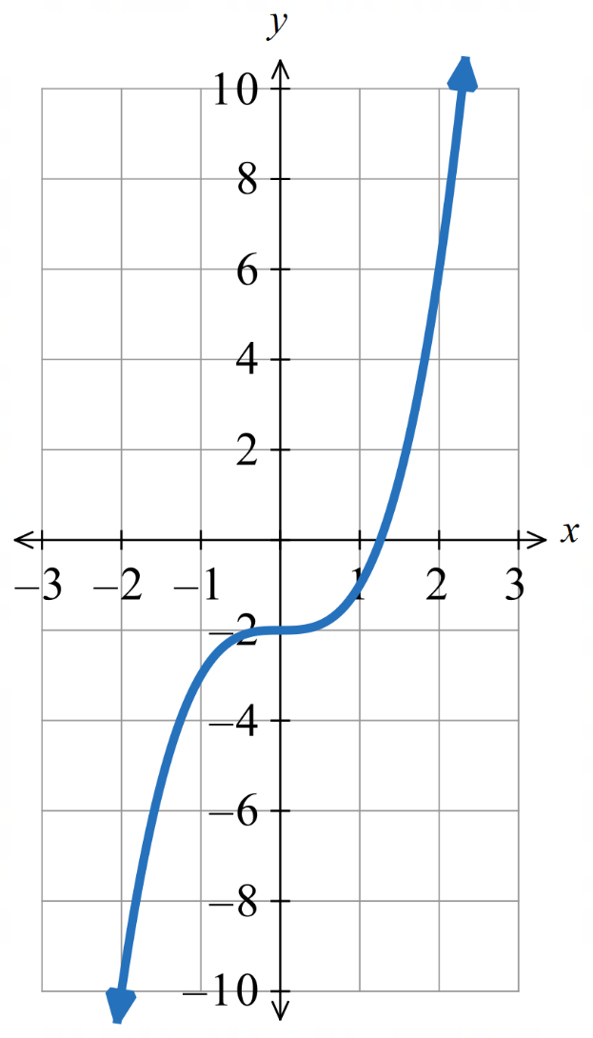 | Draw the graph of $y=-x^{3}+1$  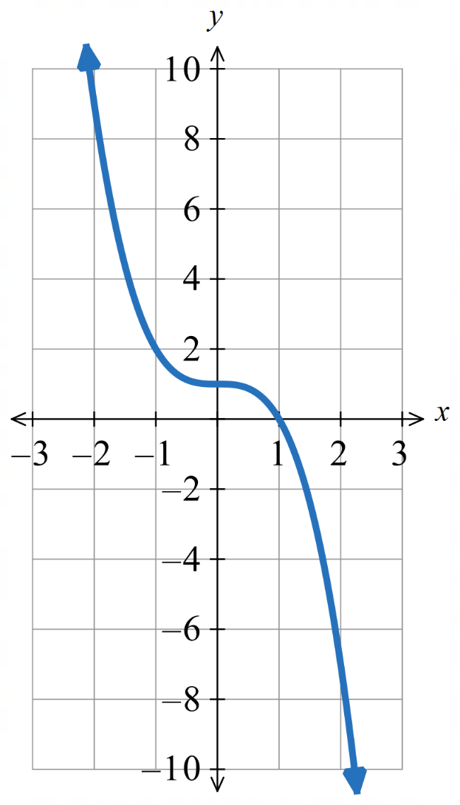
  $$x$$ | $$-2$$ | $$-1$$ | $$-\frac{1}{2}$$ | $$0$$ | $$\frac{1}{2}$$ | $$1$$ | $$2$$
  $$y$$
  $$x$$ | $$-2$$ | $$-1$$ | $$-\frac{1}{2}$$ | $$0$$ | $$\frac{1}{2}$$ | $$1$$ | $$2$$
  $$y$$

- Cubic Curve Transformations
For a cubic curve $y=k{\left(x-b\right)}^{3}+c$
The parameters $b,c,k$ affect the graph in predictable ways.
$k>0$, the curve is increasing.  $$y=1x^{3}$$  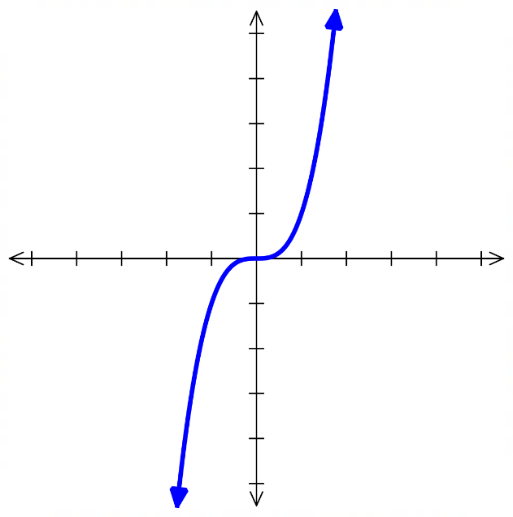 | $k<0$, the curve is decreasing  $$y=-1x^{3}$$  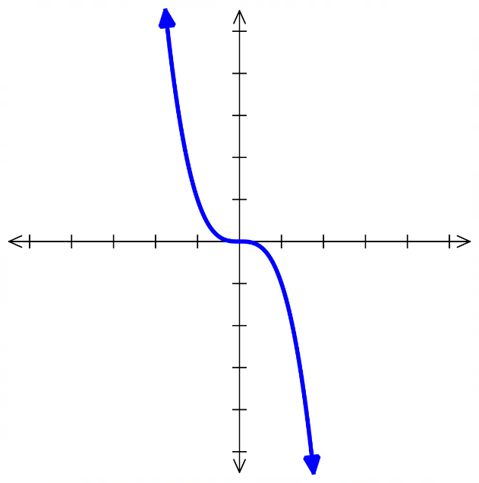
$b>0$, the curve is shifted ……………  $$y={\left(x-2\right)}^{3}$$  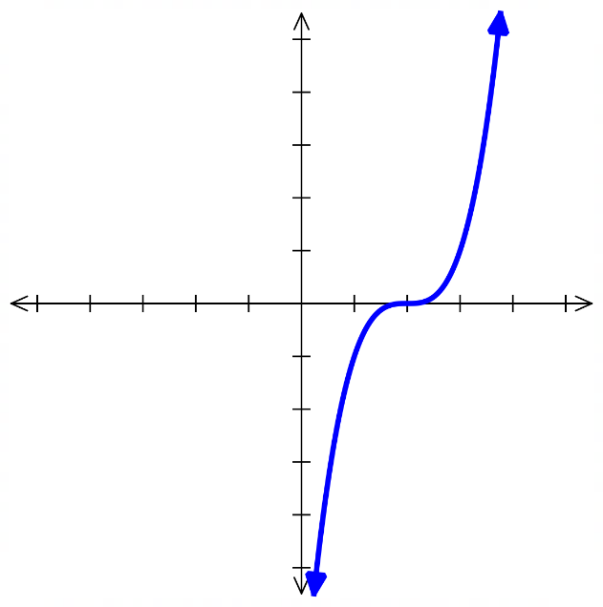 | $b<0$, the curve is shifted ……………  $$y={\left(x+2\right)}^{3}$$  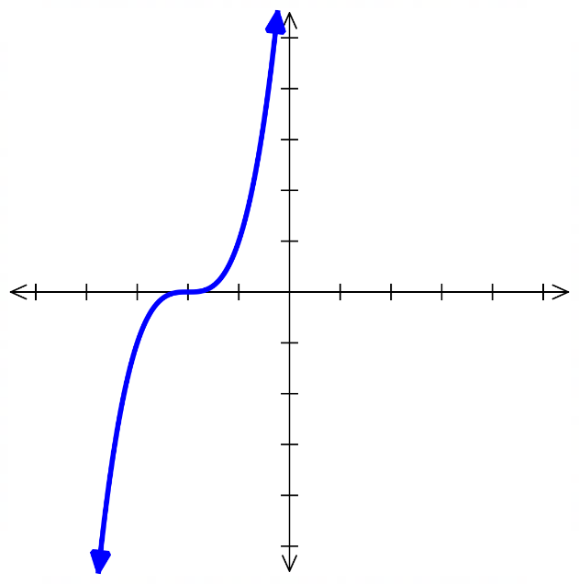
$c>0$, the curve is shifted ……………  $$y=x^{3}+2$$  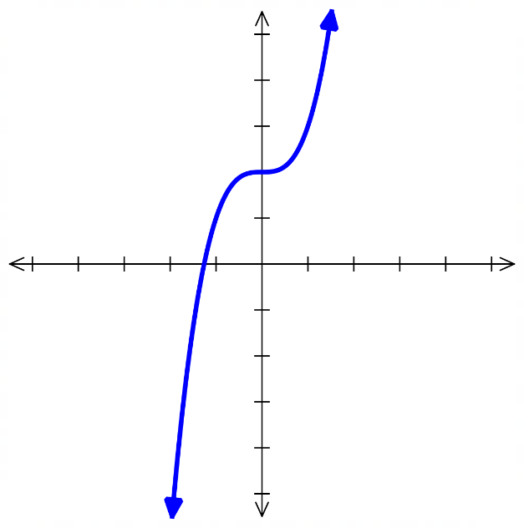 | $c<0$, the curve is shifted ……………  $$y=x^{3}-2$$  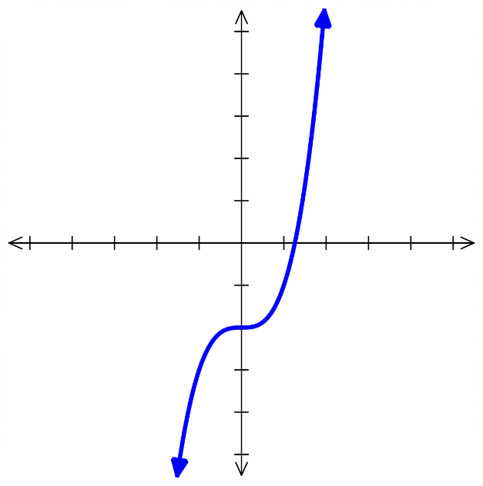
$\left|k\right|>1$, the curve gets narrower.  $$y=5x^{3}$$  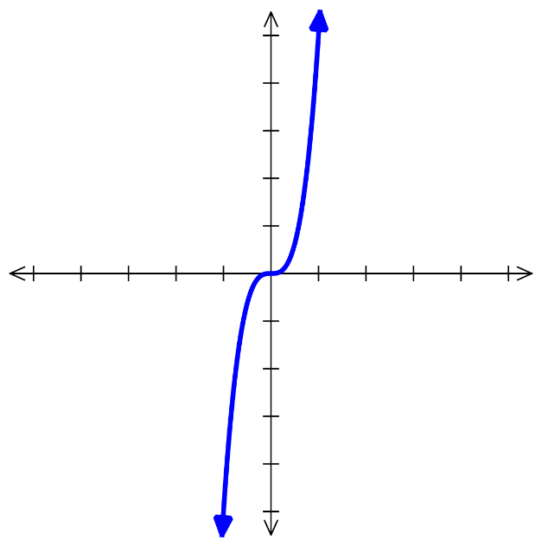 | $0<\left|k\right|<1$ the curve gets wider.  $$y=\frac{1}{5}x^{3}$$  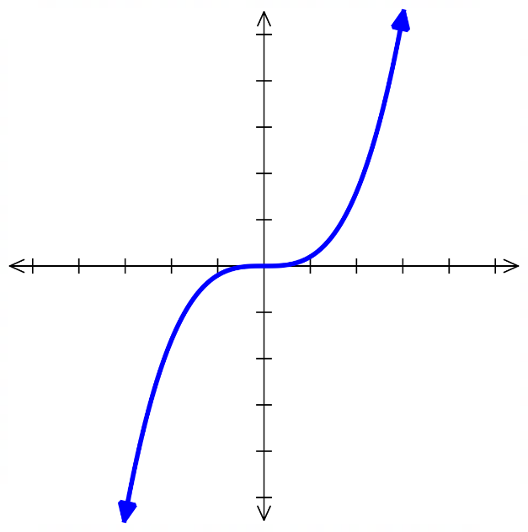
- Inflection Point Form of a Cubic Curve
The inflection point form of a cubic reveals its inflection point because it shows the graph’s horizontal and vertical shifts.

$$y=a{\left(x-h\right)}^{3}+k$$

Concavity inflection point $\left(h,k\right)$
To sketch a cubic curve:
- Determine the behaviour of curve by substituting $x→∞$.
- Find $y$-intercept by letting $x=0$.
- Find $x$-intercepts by letting $y=0$.
- Identify the point of inflection $\left(h,k\right)$.

- Example Success Criteria
Sketch $y=x^{3}-8$
1. Behaviour When $x→∞, y→∞$  2. $y$-int Let $x=0$  $y=0^{3}-8$  $=-8$  3. $x$-int Let $y=0$  $0=x^{3}-8$  $8=x^{3}$  $2=x$  4. Point of inflection at $(0,-8)$ | 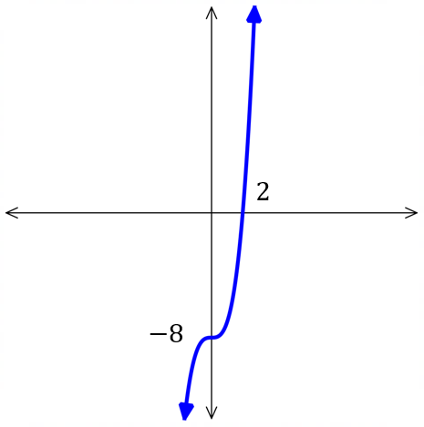

- Guided Practice
Sketch $y=-x^{3}+8$
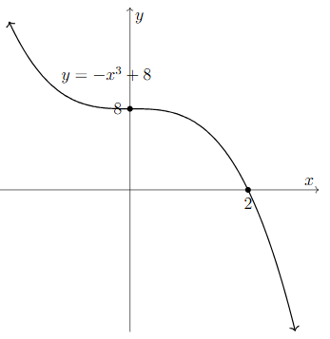

- Guided Practice
Sketch $y={\left(x-4\right)}^{3}$
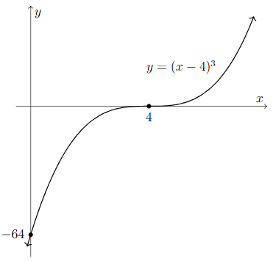

Sketch $y={\left(x+7\right)}^{3}-3$
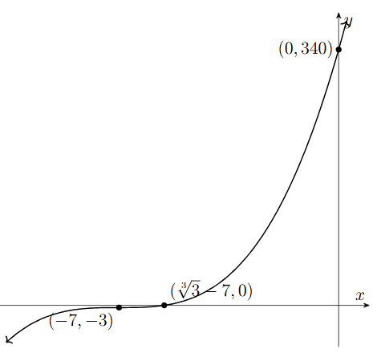

Sketch $y={-2\left(x-5\right)}^{3}+1$
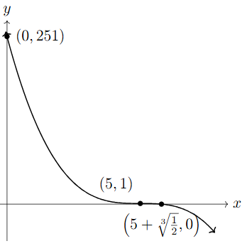

Power Curve Transformations

- Power Curve Transformations
For a power curve $y=k{\left(x-b\right)}^{n}+c$
The parameters $b,c,k,n$ affect the graph in predictable ways.
$n$ is even, curve has a turning point.
$n$ is odd, curve has inflection point.
As $n$ increases, the curve gets …………… but the turning/inflection point gets ………………
$y=x^{2}$ $y=x^{3}$ $y=x^{4}$ $y=x^{5}$
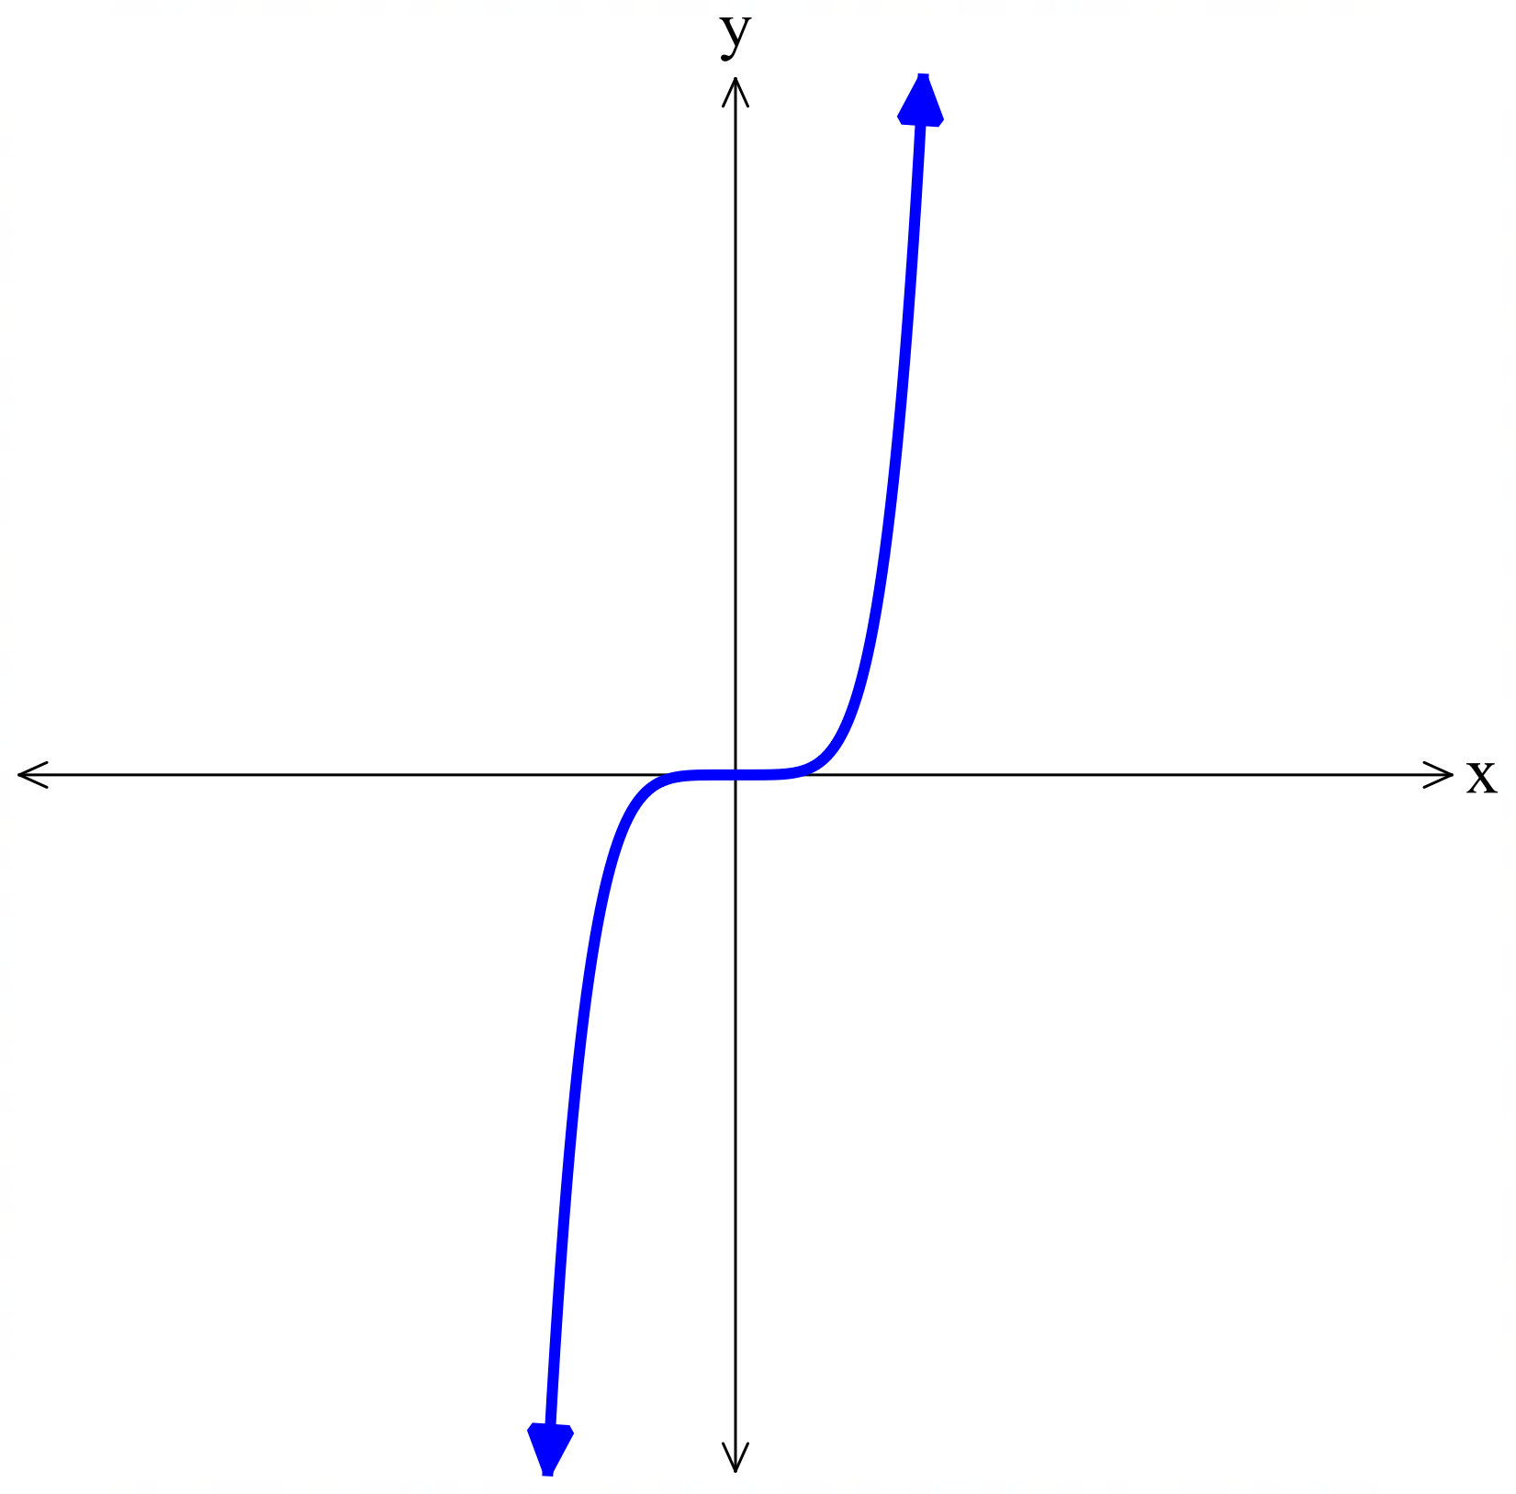
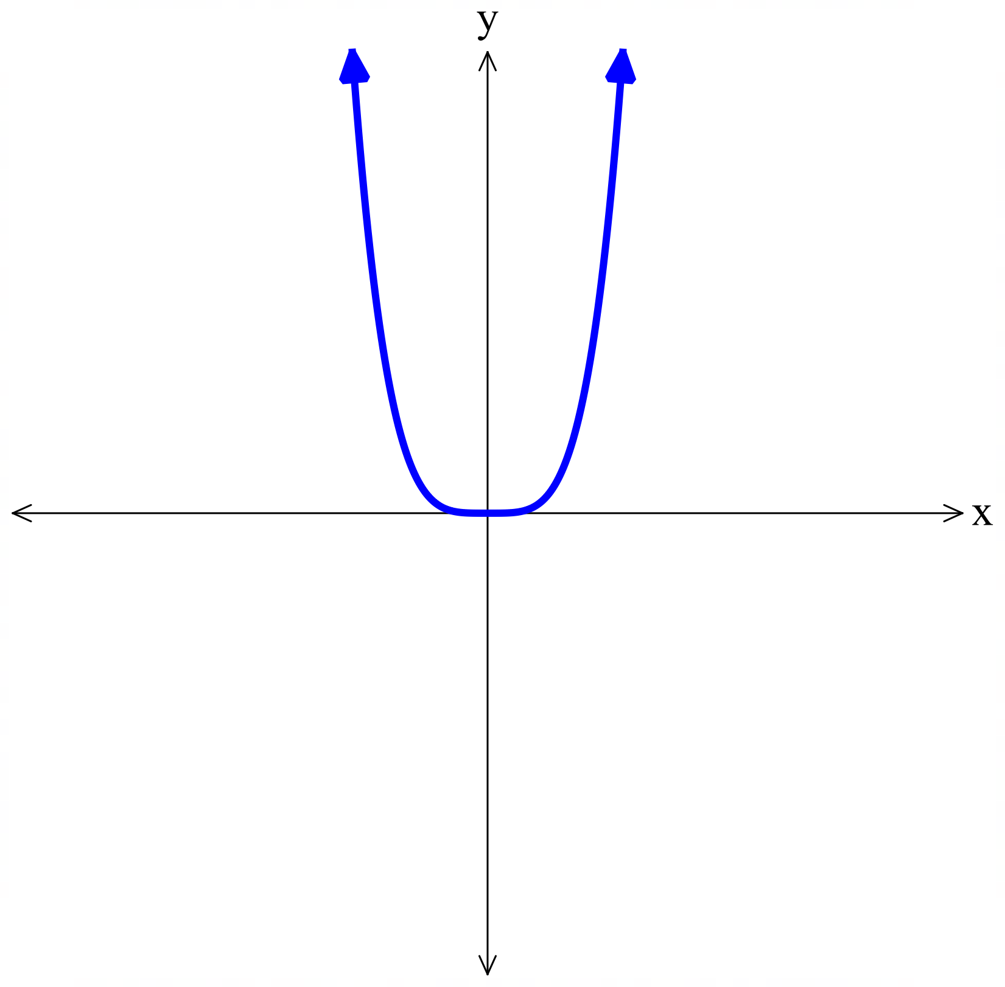
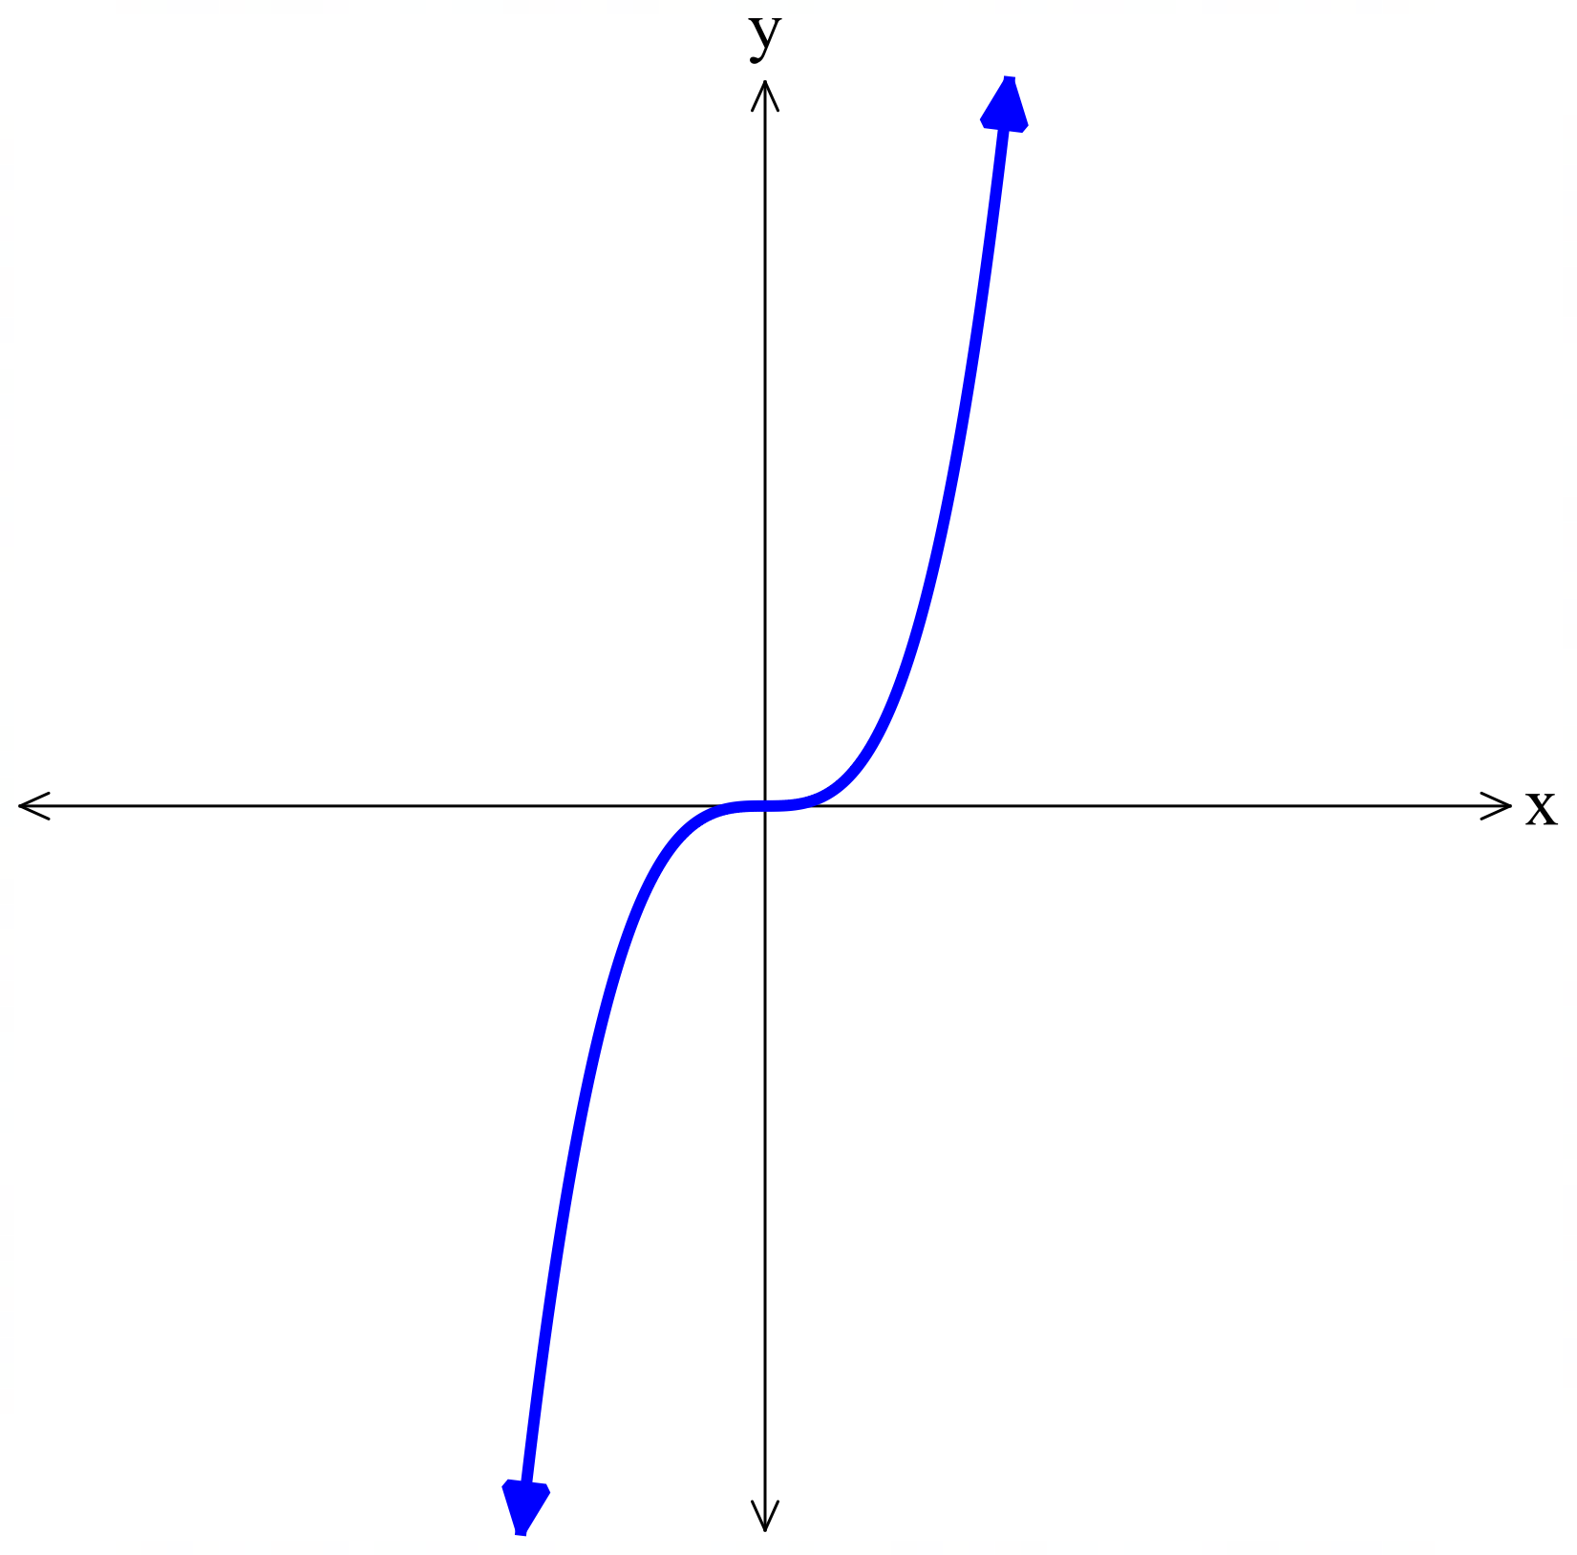
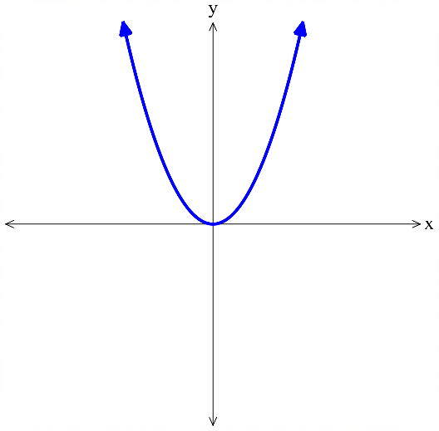

$b>0$, the curve is shifted ……………  $$y={\left(x-2\right)}^{3}$$ | $b<0$, the curve is shifted ……………  $$y={\left(x+2\right)}^{3}$$
$c>0$, the curve is shifted ……………  $$y=x^{3}+2$$ | $c<0$, the curve is shifted ……………  $$y=x^{3}-2$$
$\left|k\right|>1$, the curve gets narrower.  $$y=5x^{3}$$ | $0<\left|k\right|<1$ the curve gets wider.  $$y=\frac{1}{5}x^{3}$$

Sketching Cubics in Factored Form

- Leading Term of a Cubic
For a cubic equation $y=ax^{3}+bx^{2}+cx+d$, $ax^{3}$ is called the leading term.
It has the biggest impact on the end behaviour of the curve.
The constant term, $d$, will tell us the $y$-intercept of the curve.

- Identify the leading term of a cubic
To find the leading term, multiply the highest power terms from each factor.
To find the constant term, multiply the constant terms of each factor.
$$y=\left(2x-3\right)\left(x-4\right)\left(x+5\right)$$  Leading term: $2x^{3}$  Constant term: $60$ | $$y=\left(3-2x\right)\left(x-4\right)\left(x+5\right)$$  Leading term: $-2x^{3}$  Constant term: $-60$
Find the leading term and constant term of these cubics.
- $y=\left(x+2\right)\left(x-1\right)\left(x-3\right)$ | - $y=-\left(x-2\right)\left(x-1\right)\left(x-3\right)$
- $y=x\left(x+5\right)\left(2x+3\right)$ | - $y=-3x\left(x-5\right)\left(2x+15\right)$
- $y=\left(3-x\right)\left(2+x\right)\left(x+5\right)$ | - $y=\left(2x-3\right)\left(3x+1\right)\left(7-x\right)$

- Sketching a Cubic Curve in Factored Form
$x$-intercepts

$$y=k\left(x-α\right)\left(x-β\right)\left(x-γ\right)$$
1. Find the leading term and determine the end behaviour as $x→∞$.
2. Find $x$ intercepts.
3. Find $y$ intercept.
Leading term positive | Leading term negative
As $x→∞$, $y→∞$ | 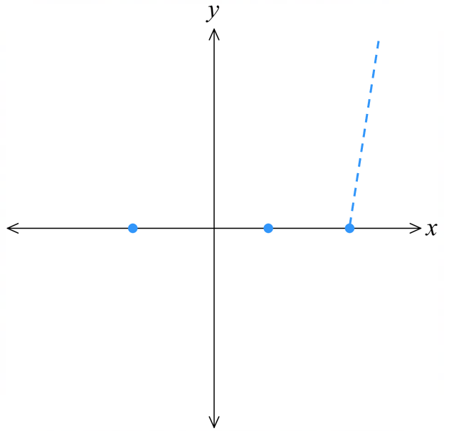  As $x→∞$, $y→-∞$  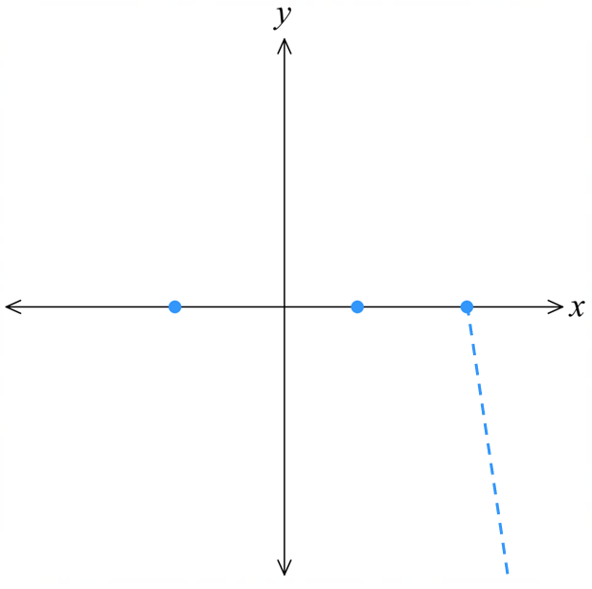

- Example Sketch cubic curves in factored form
Sketch $y=(x+2)(x-1)(x-3)$  1. The leading term is $x^{3}$,  so when $x→∞$, $y→∞$  2. Let $y=0$  $0=(x+2)(x-1)(x-3)$  $x=-2, 1, 3$  3. Let $x=0$  $y=(0+2)(0-1)(0-3)$  $=(2)\left(-1\right)(-3)$  $=6$ | 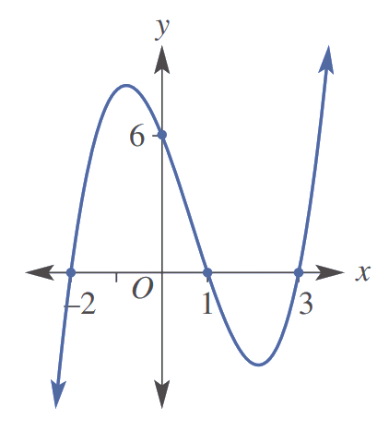

- Guided Practice
Sketch these cubic curves.
- $y=\left(x-4\right)\left(x+5\right)\left(x-3\right)$
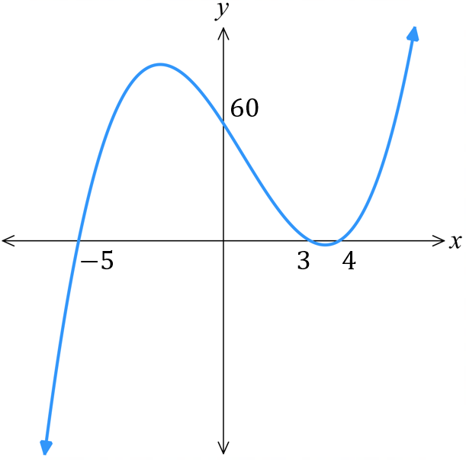
1. leading term & behaviour

2. $x$-intercepts

3. $y$-intercept

- $y=x\left(x-2\right)(x+3)$
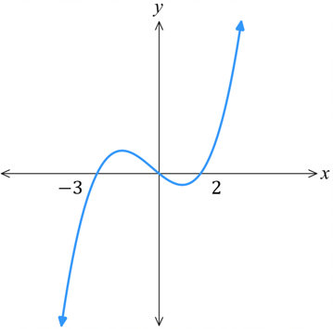

- $y=\left(x-4\right)\left(x+5\right)\left(x-3\right)$
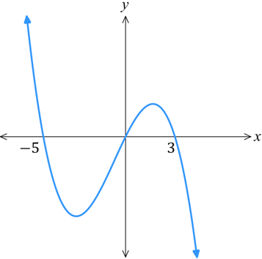

- $y=\left(3-x\right)(x+1)(2x+1)$
